4-LEVEL MAP ANALYSIS
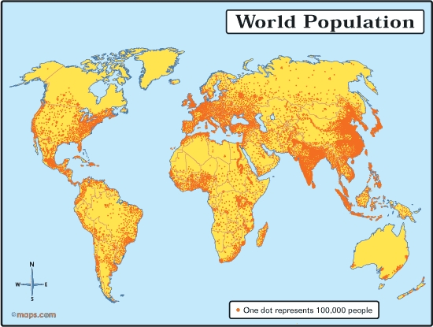

Level 1: WHAT
Level 2: WHERE
Level 3: WHY THERE
Level 4: SO WHAT

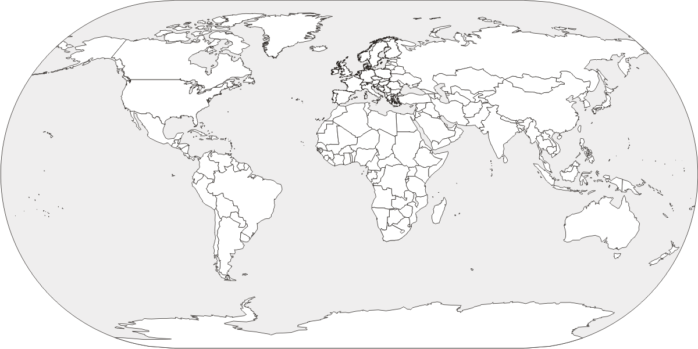
Largest and Smallest Populations
LARGEST | SMALLEST
TRENDS?

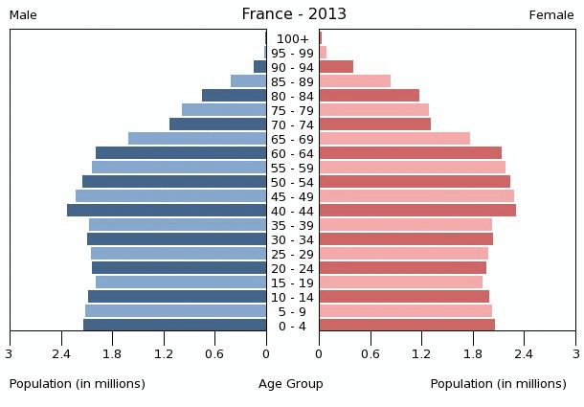
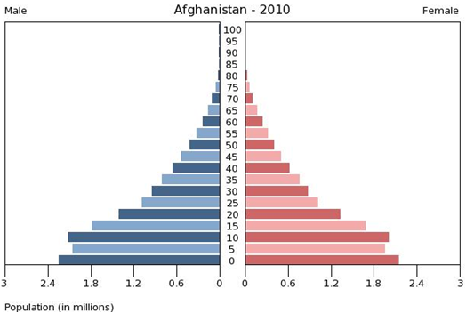
Population Pyramids:

