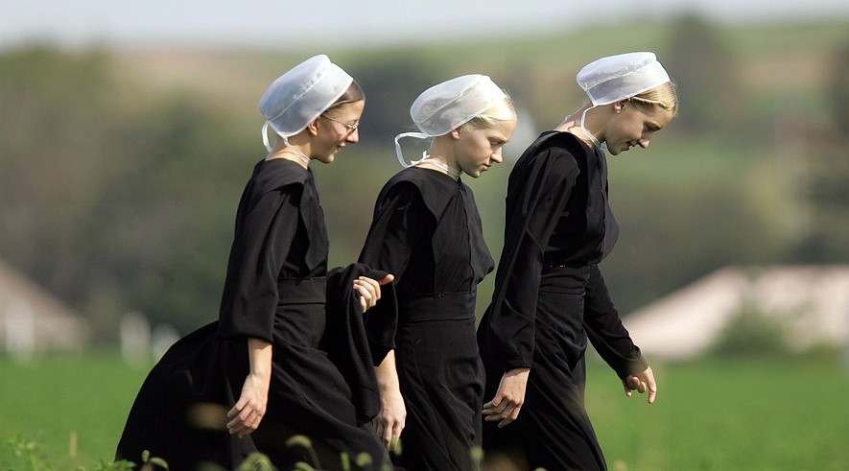
Tight-knit Amish communities have devised their own health care system
By Reuters, adapted by Newsela Staff
Oct. 11, 2013

GORDONVILLE, Pa. - Debate over U.S. health care reform has gripped the nation and led to a government shutdown. But all that doesn't much concern people in rural Pennsylvania's Amish country.
There is a very simple reason. The Affordable Care Act, popularly known as Obamacare, requires most Americans to buy some type of health insurance. But the Amish here have the legal right to choose not to purchase insurance. And that's just what they've chosen to do.
It's not that the Amish don't like health insurance. It's just that they insure themselves.
"We have our own health care," said a retired Amish carpenter. Like other Amish interviewed for this story, he asked that his name not be used because of a traditional dislike for bringing attention to oneself. "They (hospitals) give you a bill," he said. "If you can't pay it, your church will."

Responsibility To The Community
Some 280,000 Amish, mostly the descendants of 18th-century German immigrants, live in close-knit communities scattered throughout the United States. The largest populations are found in Pennsylvania, Ohio and Indiana. Their religious traditions lead them to reject cars and many other modern technologies, and also make them believe they should take care of themselves.
Most Amish get their health care through a system that depends on church aid, benefit auctions and discounts from local hospitals. Typically, hospitals are promised quick cash payment in exchange for lower rates.
"The way they come together to pay for health care is amazing," said Jan Bergen, chief operating officer at Lancaster General Health. "Their sense of responsibility extends beyond themselves and to the community."
The source of the Amish right to decline Obamacare dates back nearly 60 years. It is rooted in their unwillingness to pay certain kinds of taxes for religious reasons.
Social Security taxes, which the government collects to provide for people after they retire, used to be paid only by employees. But during the 1950s Congress extended the tax to the self-employed and to farmers. Many Amish refused to pay. The Internal Revenue Service (IRS) moved to enforce the law, sometimes in very unpopular ways.

Paying Their Own Way
"There was an Amish guy who refused to pay Social Security. IRS agents confiscated his horses while he was out in the field plowing," said Donald Kraybill, author of "The Amish" and a professor at Elizabethtown College in Pennsylvania.
The Amish position was that they shouldn't have to pay for government services they didn't want. In 1965, Congress passed a law giving many Amish the right to decline Social Security, Medicaid and other government benefits.
"The basic religious reason driving their resistance is that, as a religious faith, the church community should take care of its own members," said Kraybill. "If there's a disaster like a tornado, fire or hospital bill, the community should come together for that."
The Amish right to decline Obamacare is based on their right to decline Social Security and other government benefits.
"We don't want government paying for our things," said an Amish man from Kinzers, Pa. "We want to pay our own way." He said his community relies on two funds. Nearly every family contributes monthly to a hospital aid fund. Large bills are paid with what are called "free-will offerings."
To help hospitals keep track, some Amish carry benefit cards. These identify them as members of a community but do not bear names or photographs.

"Mud Sales" For Bigger Bills
One central part of Amish life keeps medical bills down: Farm work and other manual labor keep the Amish active for most of their lives. As a result, they are less likely than the average American to develop diabetes and heart disease, among other illnesses.
But Amish children are more likely than average to suffer from certain genetic diseases. This is due to the Amish population's small size and high rates of marrying within the community.
For the heaviest bills, Amish communities often turn to benefit auctions. These are nicknamed "mud sales" because of the often muddy fields where they are held. At a recent Saturday auction in Gordonville, young Amish men bid used buggies up to more than $4,000. Hand-made quilts sold for several hundred dollars each.
Most mud sales and auctions benefit particular institutions. The one in Gordonville helped pay the bills for a volunteer ambulance company. But a series of five held across the state each year help fund the Clinic for Special Children, a world-class hospital for children with genetic diseases.
Many Amish at the auction said they had relied on hospital aid to pay their medical bills.
"It's not stressful," said an Amish man at the auction. "It's there when you need it."

