Asia Climate Map (Document 1)

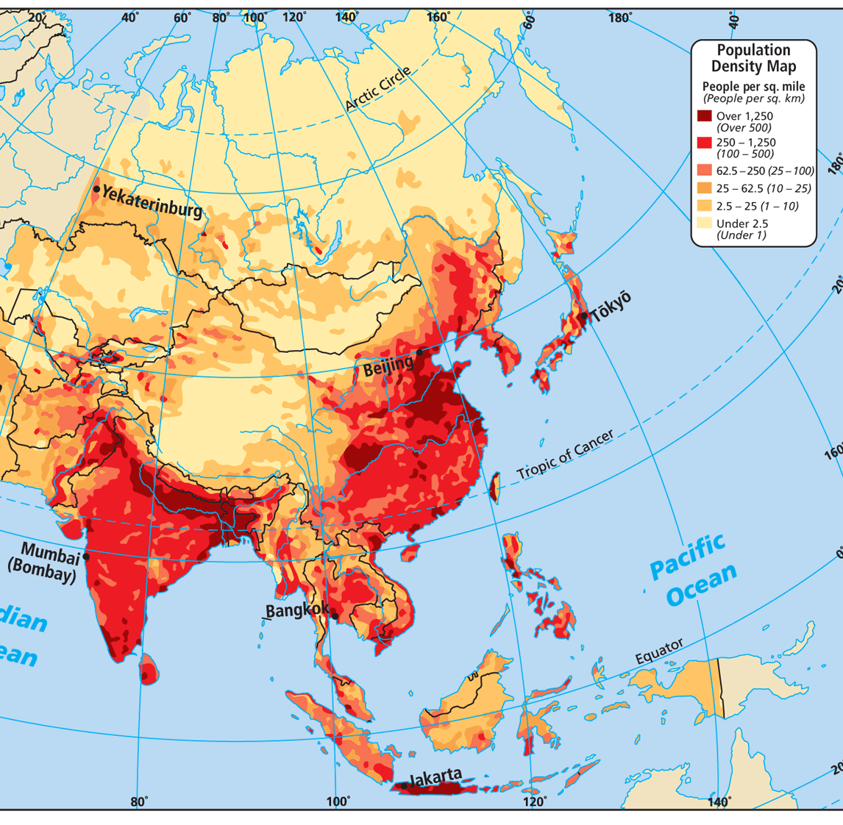
Asia Population Density Map (Document 2)

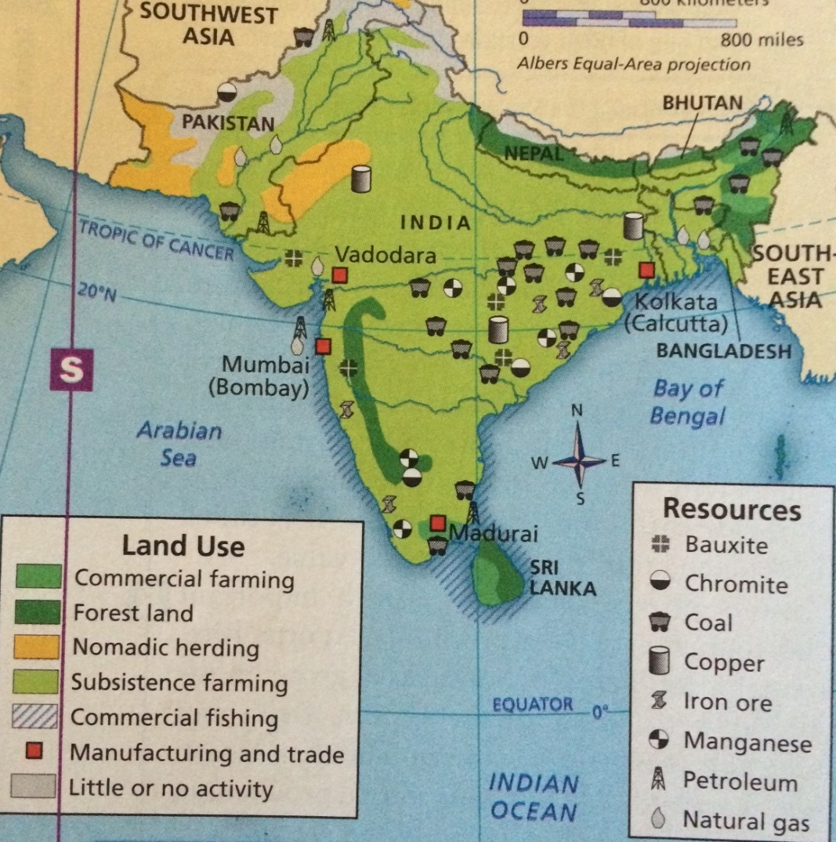
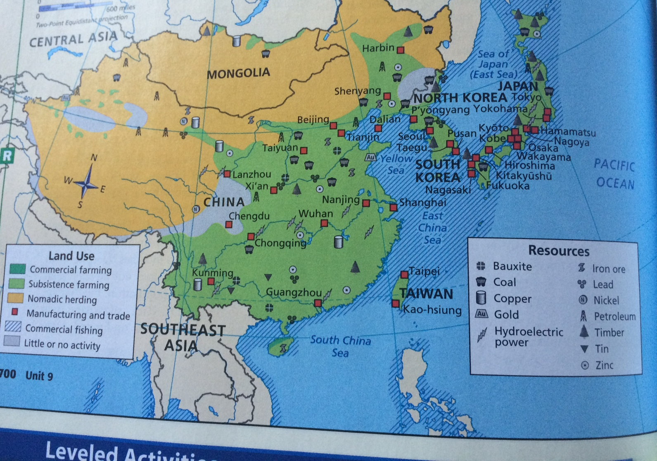
East Asia and South Asia Natural Resource Map (Document 3)

Southeast Asia Natural Resource Map (Document 4)

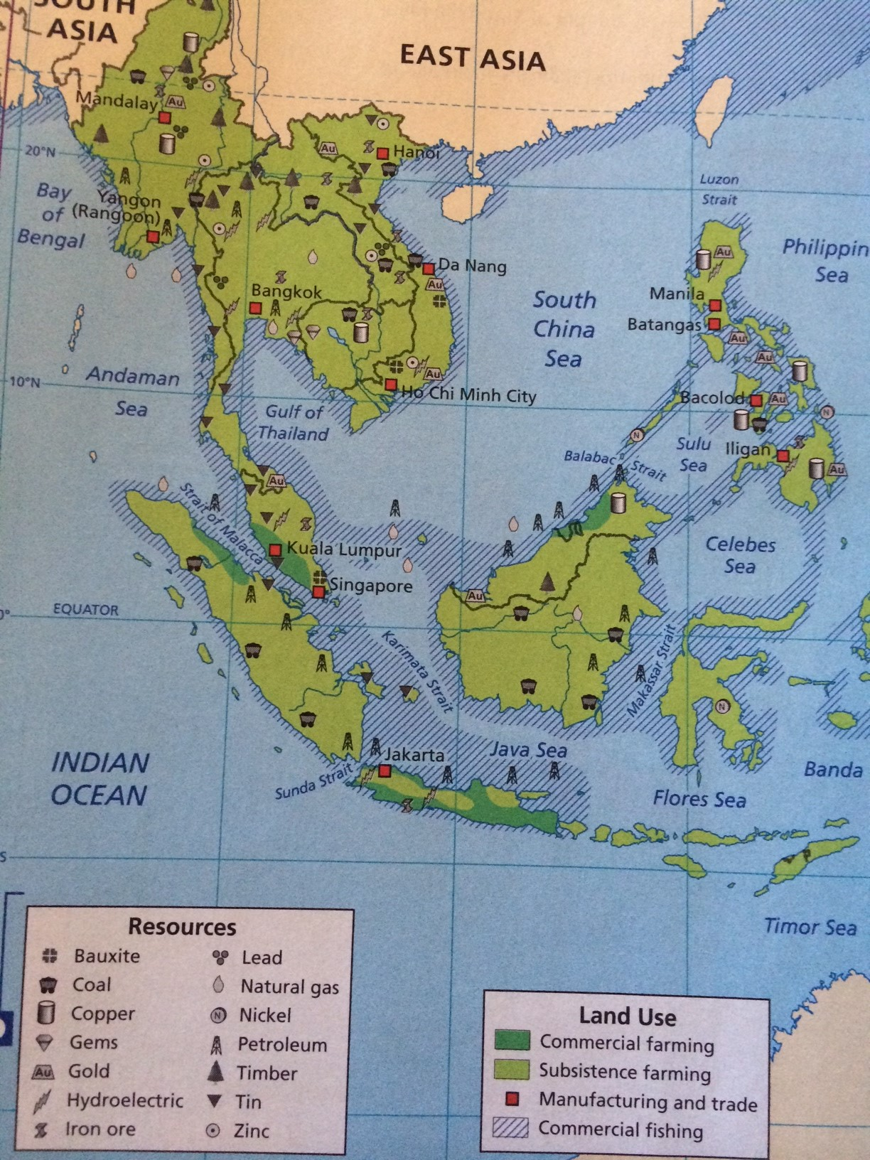

Political Map of Asia (Document 5)

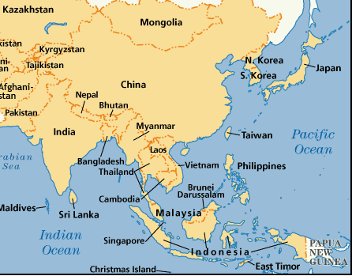

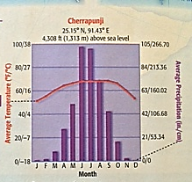
Average Temperature and Precipitation (rainfall) Map (Document 6)
Cherrapunji, India

Indian Monsoon Celebration Passage
(Document 7)

The people, animals, and scorched landscape of India wait eagerly each year for the marriage of cool ocean winds with hot, dry air. Indian short story writer Shantipriya describes the coming of the monsoon season this way: “The air is on fire and leaves are perfectly still as if holding their breath.” When the skies open, there is cause for celebration, as the storms insure that nearly a billion people will have food on their table. The vegetation provides food and shelter for much of the country’s wildlife. Though sometimes violent and destructive, these rains, according to Shantipriya, make “rivers flow and flowers bloom in celebration of the monsoon, as the world is transformed under spell.”

Monsoon Damage Passage
(Document 8)

The monsoons are both feared and anticipated by the people of South Asia. Although they bring badly needed rain, they can sometimes bring death and destruction as well. In 2005, the city of Mumbai (Bombay) experienced the devastating effects of monsoon rains: 37 inches of rain fell within a few hours, causing heavy flooding—neck-high in some places. Many people across the country died from drowning, suffocation, and disease. Residents suffered from a lack of preparation and inadequate response on part of the local government. When it was all over, more than 1,000 Indians lost their lives in this natural disaster.

