Name:________________________ Date:______________

1. Directions: Use your smart phone or class computers to find out the top 10 countries (largest amount of followers) of your assigned religion and fill in the chart below.

Countries from most to least | # of followers | % of people

2. Directions: Shade in the top 10 countries for your assigned religion on the world map below. You may use your phone or desk map as a reference.
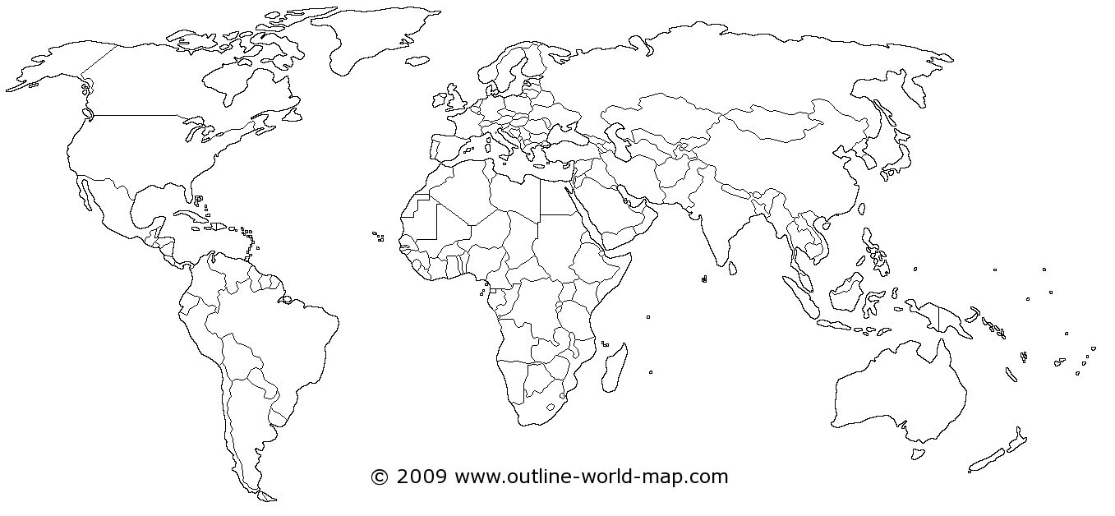

3. What patterns or trends do you see? ____________________________________________________________________________________________________________________________________________________________________________________________________________________________________________________________________________________________________________________________________________________

