Item 1

11/17/2014- President Barack Obama vetoed Congress’ bill called the Interstate Recognition of Notarizations Act of 2010, so it never became a law.
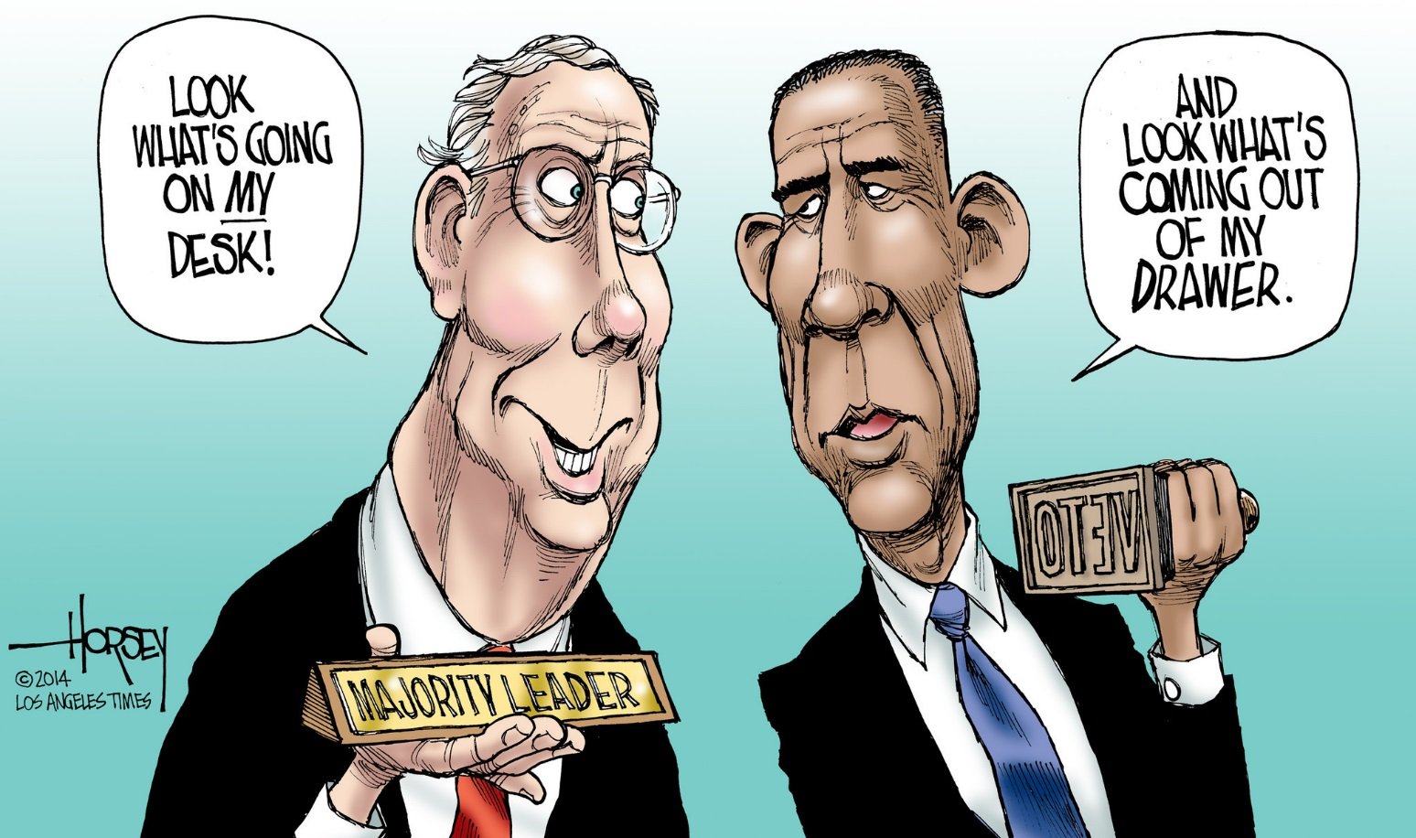

Item 2

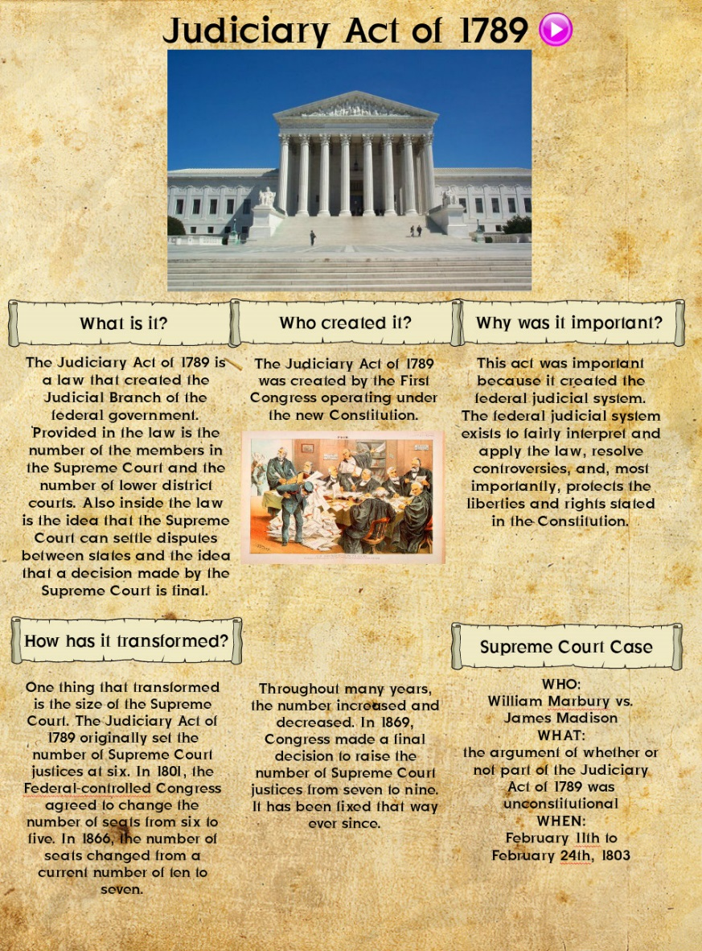
The Judiciary Act of 1789 stated that Congress could establish a Federal Court System through the Judiciary Act. So, congress has the power to make and get rid of the courts.

Item 3

In November 2007, President Bush’s veto of the Water Resources Development Act of 2007 was overridden by congress, so the act was passed.

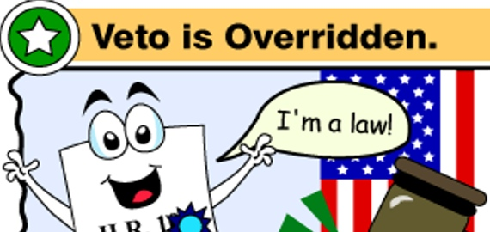

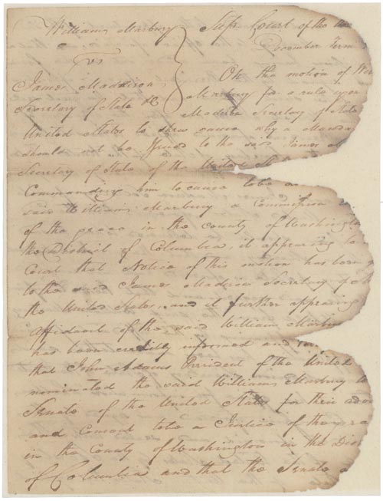
Item 4
Draft of motion rule for Marbury Vs. Madison.
This document is an order to show cause in the Marbury v. Madison Supreme Court case in 1803. This case established the idea of judicial review, the ability of the Supreme Court to overturn a law because it goes against the Constitution, or is unconstitutional. The Supreme Court is the final authority on the meaning of the Constitution.
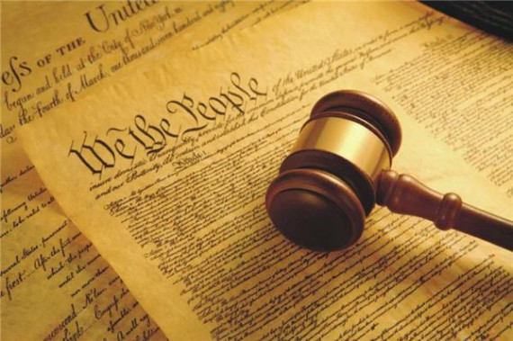

Item 5
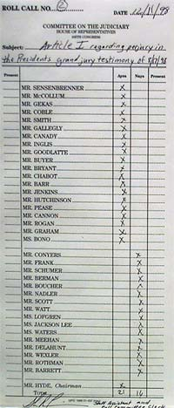
Roll call votes regarding the impeachment, or removal, of President Andrew Johnson by Congress.
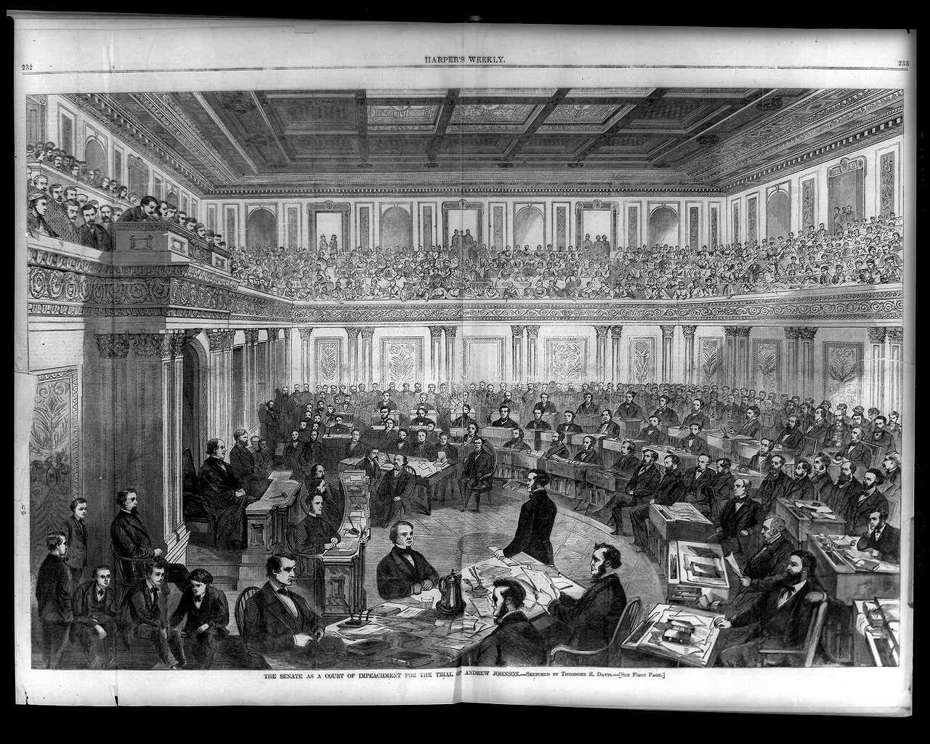

Item 6
Message of President John Adams nominating, or appointing, John Marshall to be Chief Justice of the Supreme Court
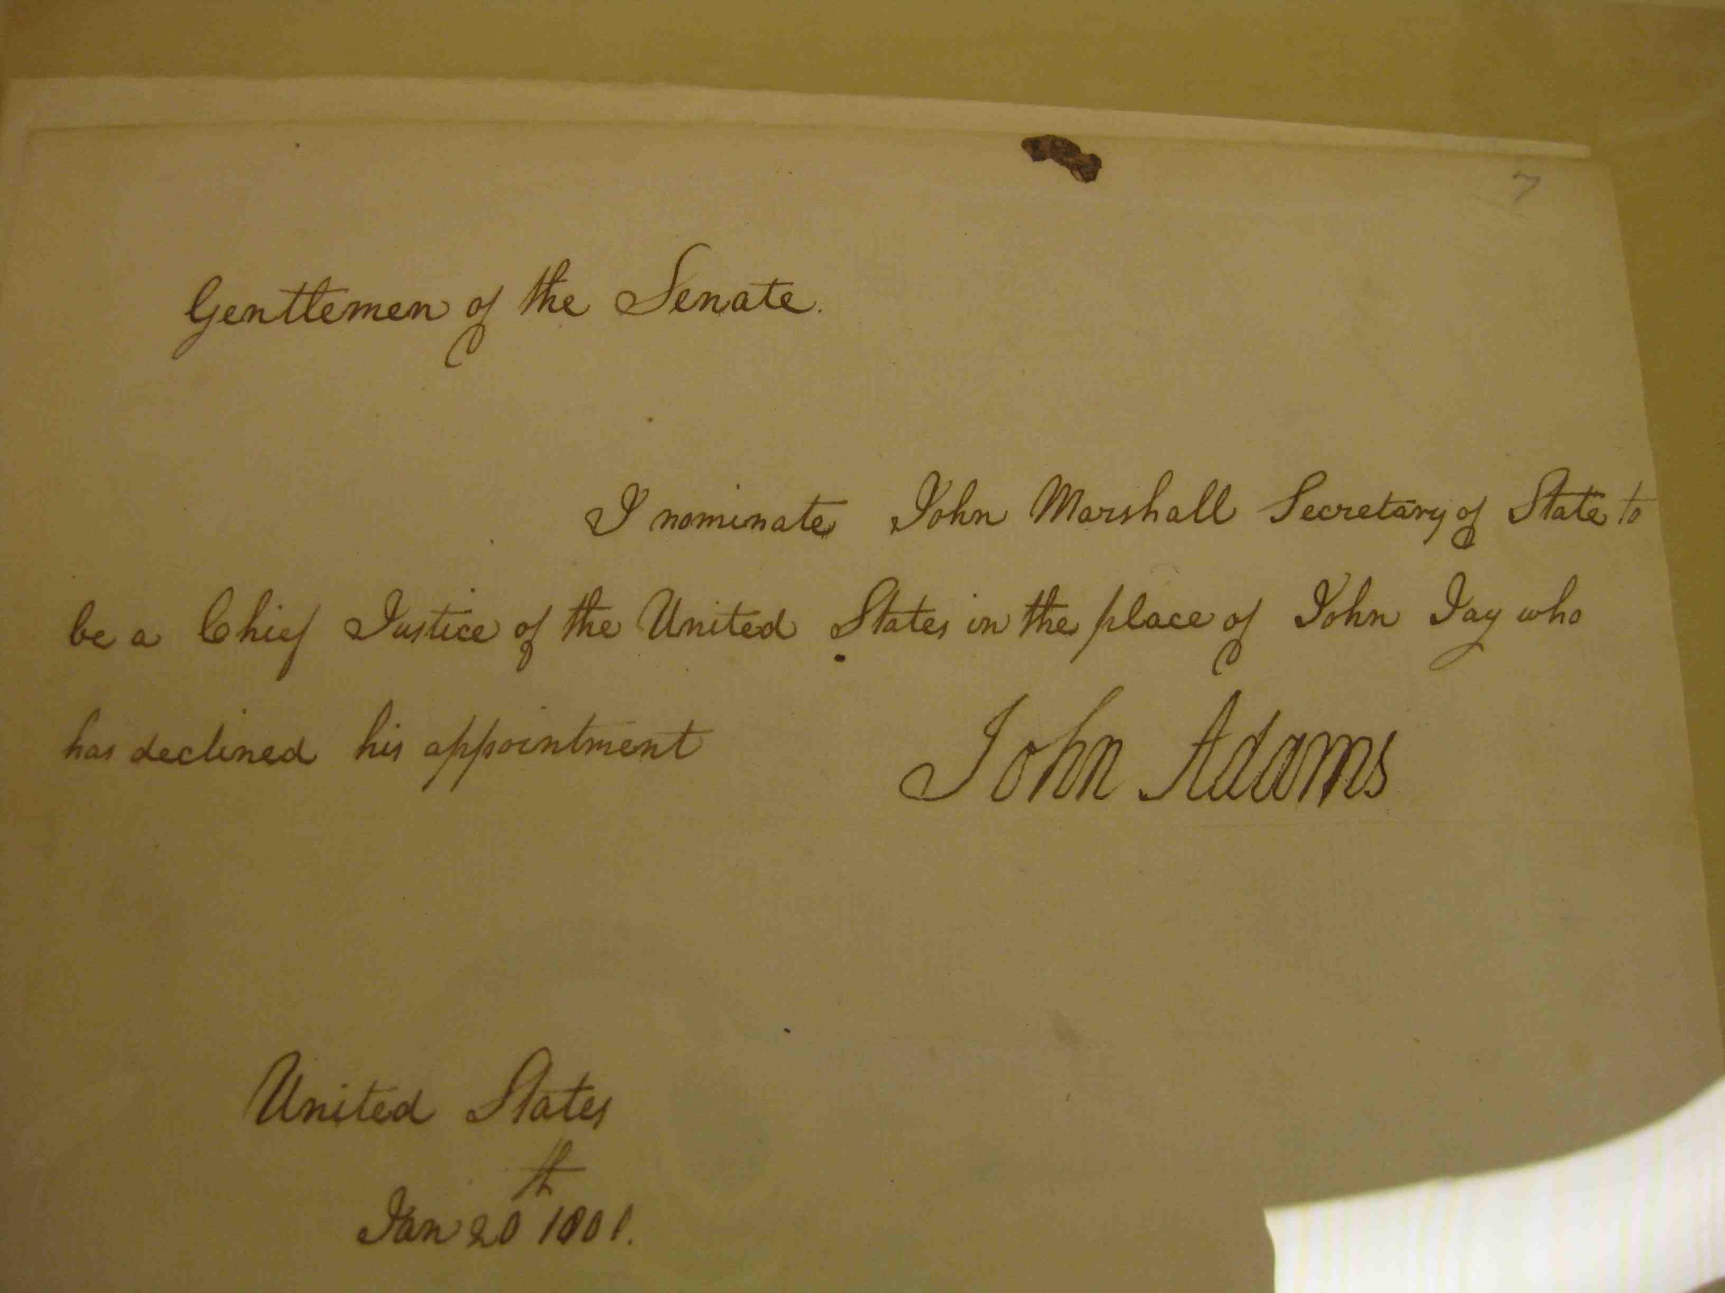

Directions: Review the documents in this folder to see examples of checks and balances throughout history. Then you will break down the documents by filling out the worksheet below. When you’re finished, silently answer the question at the bottom.
Item | Branch checking | Branch being checked | How are they being checked?
1
2
3
4
5
6

According to your checks and balances chart and your document analysis, in 3-5 sentences explain which branch you think has the most important check. Why do you think that check is the most important? (There is not right answer to this question!!) ____________________________________________________________________________________________________________________________________________________________________________________________________________________________________________________________________________________________________________________________________________________________________________________________________________________________________________________________________________________
Name:_______________________ Date:________________
Bell Ringer
Directions: Use the political cartoon on the board to silently answer the following questions in complete sentences. When you’re finished, make a name tag by folding your blue cardstock in half and write your first name on it in big letters.

- What do the three heads represent?
____________________________________________________________________________________________________________________________________________________________________________________________________2. How do the three heads interact with each other? How do you know?
______________________________________________________________________________________________________________________________________________________________________________________________________________________________________________________________________________________________________

- What does this cartoon tell you about our government? How do you know?
______________________________________________________________________________________________________________________________________________________________________________________________________________________________________________________________________________________________________
Today’s Objective
____________________________________________________________________________________________________________________________________________________________________________________________________
Key Terms:
1. Separation of Powers: ___________________________________________________________________________________________________________________________________________________________________________________________________
2. Checks and Balances: ___________________________________________________________________________________________________________________________________________________________________________________________________
Video Guide
Directions: Fill in the chart below with your partner after watching the video.
LEGISLATIVE | EXECUTIVE | JUDICIAL
WHO’S IN IT? | WHO’S IN IT? | WHO’S IN IT?
1 POWER THEY HAVE | 1 POWER THEY HAVE | 1 POWER THEY HAVE
Name:____________________ Date:_______________
Exit Slip

Directions: Silently circle the correct answer.

- A spot on the Supreme Court just opened up because someone retired. President Obama appoints someone but Congress rejects his appointment. This is an example of:
- The executive branch using veto power to check congress
- Congress using a vote to reject an executive appointment to check the executive branch.
- The Judicial Branch using judicial review to check congress.
- The executive branch overriding a veto to check congress.

- The division of our government into three branches is called:
- Checks and balances B. Division of labor C. Separation of powers D. The Bill of Rights

- If congress passes a bill, but the president doesn’t agree with it he can
- Override it B. Use Judicial Review to reject it C. Veto it D. Appoint it

- How can congress check the president?
- They can impeach, or try to remove, the president.
- They can veto his ideas for bills.
- They can declare his acts unconstitutional.
- They can appoint members to his cabinet.

Name:______________________ Date:_______________
Exit Slip

Directions: Silently circle the correct answer.

- A spot on the Supreme Court just opened up because someone retired. President Obama appoints someone but Congress rejects his appointment. This is an example of:
- The executive branch using veto power to check congress
- Congress using a vote to reject an executive appointment to check the executive branch.
- The Judicial Branch using judicial review to check congress.
- The executive branch overriding a veto to check congress.

- The division of our government into three branches is called:
- Checks and balances B. Division of labor C. Separation of powers D. The Bill of Rights

- If congress passes a bill, but the president doesn’t agree with it he can
- Override it B. Use Judicial Review to reject it C. Veto it D. Appoint it

- How can congress check the president?
- They can impeach, or try to remove, the president.
- They can veto his ideas for bills.
- They can declare his acts unconstitutional.
- They can appoint members to his cabinet.

