Term | Meaning
Class #6 Notes

Demographics:
Age
Sex

Race-__________________________________________________________________________________________________________________________________________________________________________

Ethnicity-__________________________________________________________________________________________________________________________________________________________________________

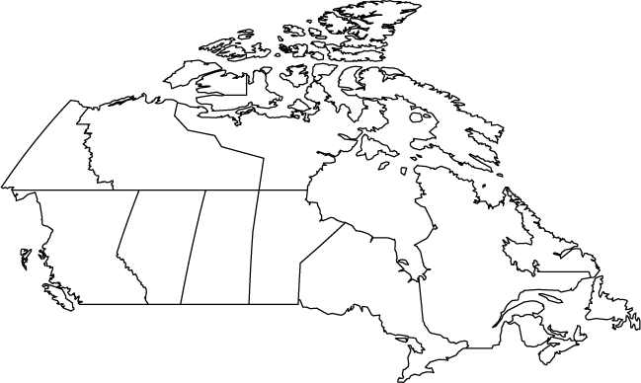
Ethnicity Example: Quebec, Canada

Population Density Activity
Your assigned continent: ______________________________
Directions: Use the population density maps in the textbook to answer the following questions about your assigned continent.

Part 1 :Answer the following questions using the map in the textbook.
1. Which color represents the MOST populated areas? _______________

2. Which color represents the LEAST populated areas?________________

3. Where are the most populated places? What do they have in common?____________________________________________________________________________________________________________________________________________________________________________________________________________________________________________________________________________

4. Where are the least populated places? What do they have in common?____________________________________________________________________________________________________________________________________________________________________________________________________________________________________________________________________________

5. What do your answers to #’s 3 & 4 tell you about where most people prefer to live? ____________________________________________________________________________________________________________________________________________________________________________________________________________________________________________________________________________________

6. Besides the physical location on the map or within a continent, what other factors might impact population density?_____________________________________________________________________________________________________________________________________________________________________________________________________________________________________________________________________________

Part 2: Use your phone or the classroom computer to look up information from the CIA or Census bureau to find out the demographics of your continent. Answer the questions below.

1. What is the racial and religious make up of your region?

2. What is the fertility rate of your region?

3. What is the infant mortality rate of your region?

4. How can the information above affect your region’s population and culture?

