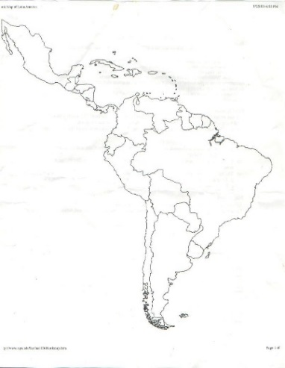
Name:________________________
Cultures in Latin America – 9/16/14 – World Geography Unit 3 Notes
Mexico:
- Indigenous Groups: ___________ in the _______________ Peninsula
  - European Settlers + Maya = ______________________ culture
- Mexico City-__________________________city in Mexico
- Indigenous religion + ______________________ = _________________________
- _________________________ is a large problem in Mexico
- ________________________ & _____________________ are two of the most famous artists from Mexico
- Extended _________________________ is very important to culture

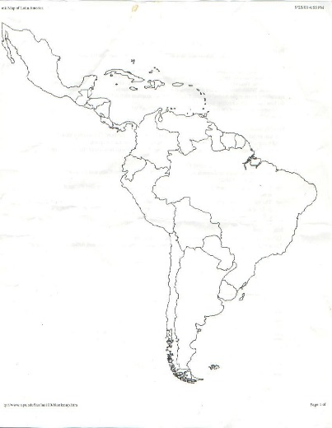
Caribbean & Central America:
- Blends of different _________________________ groups ___________________ Mestizos
- Urban ____________________ – cities ________________
- ______________ Exchange trade from _______________to ____________
- Spanish, French, Dutch (mainly _______________________)
- __________ Roman Catholic
- Matriarchal- house is run by the _______________________
- _______________ made up of Islands some under _______________control

South America:
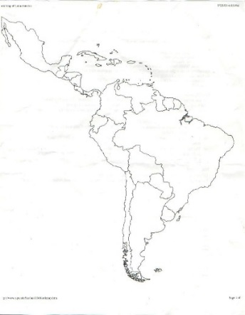
- 350 different_______________ groups
- Sao Paulo, ____________________ & Buenos Aires, ________________________ are
2 of the largest cities in the world
- Spanish, Portuguese and ______________ are spoken
- Most are _____________ Catholic, but also many other _______________________
- ___________ is very important to the _________________________
- _____________ family is very important to many __________________

One sentence summaries:

1. Culture of Mexico: ______________________________________________________________________________________________________________________________________________________________________________________________________________

2. Culture of Caribbean Islands/ Central America: ______________________________________________________________________________________________________________________________________________________________________________________________________________

3. Culture of South America: ______________________________________________________________________________________________________________________________________________________________________________________________________________

9/16/14- Unit 3, Day 3. Cultural Geography of Latin America
1. Bell Ringer: Put the countries and terms listed below into the correct categories by writing them in the boxes.
Mexican plateau, Brazil, El Salvador, Argentina, Amazon Rainforest, Colombia, Panama, Argentina, Andes Mountains, Spanish, Latin America, Island, Puerto Rico.

Central America/Caribbean | Mexico | South America

2. Choose one vocab word from your Unit 3 Vocab Matrix (on the back of your Unit 3 calendar) and do the following below:
1. Describe the word
2. Give an example
3. Draw an image
4. Use it in a sentence

Word you chose:______________________
Description
Example
Image
Sentence

