Name:__________________________ Date:_______________
Unit 6 Day 1
Productive Civic Life
Bell Ringer: Describe someone who you admire. Why do you admire them? What makes them a good person in your eyes? (4-6 sentences)
________________________________________________________________________________________________________________________________________________________________________________________________________________________________________________________________________________________________________________________________________________________________________________________________________________________________________________________________________________________________________________________________________________________________________________________________________________________________________________________________________________________________________________________________________________________________________________________________________________

Today’s Objective
____________________________________________________________________________________________________________________________________________________________________________________________________
Productive Citizenship

A productive citizen is someone who contributes positively to society. There are many aspects of what makes up a productive citizen, but just because someone does not have every single one of the following qualities, does not mean that they do not contribute positively to society.

Productive citizens usually: Finish school because educated people make more money and have more skills. They register to vote so that they have a say in our government. They attend jury duty to help in the judicial process. They respect others’ opinions. They join or support the armed forces, and are informed about current issues. They obey the law and pay taxes on time.
Qualities of a Productive Citizen

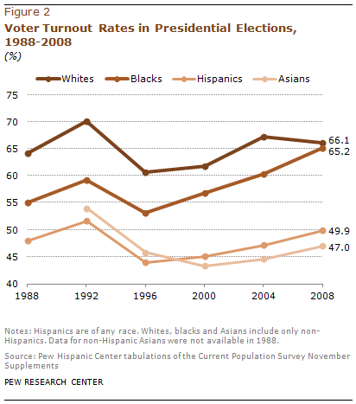
Voter Participation by Race

1. Describe the general findings of the graph.
______________________________________________________________________________________________________________________________________________________________________________________________________________________________________________________________________________________________________
2. According to the graph, which year had the highest turnout for elections by all races? __________________________
3. Why do you think some eligible voters choose not to vote during an election? ____________________________________________________________________________________________________________________________________________________________________________________________________
4. Will you vote during elections when you turn 18? Why or why not? ______________________________________________________________________________________________________________________________________________________________________________________________________________________________________________________________________________________________________

