Documents on UC-Davis Protest – November 18, 2011

Document 1:

“UC Davis Protestors Pepper Sprayed”
https://www.youtube.com/watch?v=6AdDLhPwpp4

Document 2:
“UC Davis Pepper Spray – What Really Happened?”
https://www.youtube.com/watch?v=hhPdH3wE0_Y

Document 3:
WASHINGTON -- On Friday, a group of University of California, Davis students, part of the Occupy Wall Street movement on campus, became the latest victims of alleged police brutality to be captured on video. The videos show the students seated on the ground as a UC Davis police officer brandishes a red canister of pepper spray, showing it off for the crowd before dousing the seated students in a heavy, thick mist.
This incident recalls the earlier infamous pepper spraying by a New York Police Department official of several women who were seated and penned in. The UC Davis images are further proof that police continue to resort to brutal tactics when confronting Occupy activists. One woman was transported to a hospital to be treated for chemical burns.
"The UC Davis students were peacefully protesting on the quad," wrote one student who took videos in an email to The Huffington Post. The filmmaker, a senior, asked that his name not be used for fear of retribution by campus authorities. "The cop gave them 3 minutes to disperse before he said they would come and disturb the protest. The main objective for them was removing the tents. ... The students did have a right to be on campus, they were assembling peacefully and the campus was open at the time."
Source: Cherkis, J. (2011, November 19). UC Davis Police Pepper Spray Seated Students in Occupy Dispute (VIDEO) (UPDATES). The Huffington Post. Retrieved April 3, 2015

Document 4:
This is a point I wish I had made the first time around. While the first 60 seconds of the 8-minute YouTube video are dominated by the shockingly calm brutality of the policeman, the rest of it is remarkable mainly for the stoicism and resolve of the protestors. You don't have to idealize everything about them or the Occupy movement to recognize this as a moral drama that the protestors clearly won. The self-control they show, while being assaulted, reminds me of grainy TV footage I saw as a kid, of black civil rights protestors being fire-hosed by Bull Connor's policemen in Alabama.

Source: http://www.theatlantic.com/national/archive/2011/11/the-moral-power-of-an-image-uc-davis-reactions/248778/

Document 5
*Background: Pictures were taken from the police response ordered by Bull Connor during Civil Rights demonstrations in Birmingham, Alabama in 1963.
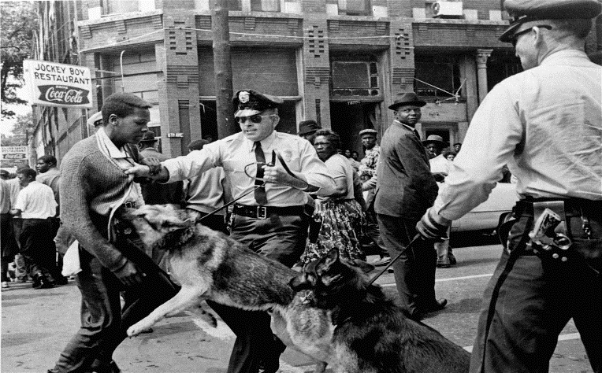
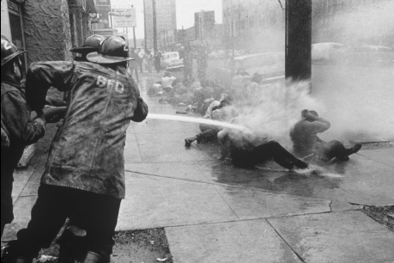

Document 6:
Amendment I: Congress shall make no law respecting an establishment of religion, or prohibiting the free exercise thereof; or abridging the freedom of speech, or of the press, or the right of the people peaceably to assemble, and to petition the Government for a redress of grievances.

(Redress of grievances = compensation/return/positive change for complaints)

Document 7:
The UC Davis police officer filmed casually pepper-spraying passive student protesters is the latest target of the computer hacking collective Anonymous.

A new 10-minute video attributed to the shadowy "hacktivist" group threatens the officer directly and makes public his personal contact information - including his cell phone number and an alleged home address.

The voicemail on the working cell number for Lt. John Pike was full Tuesday.

"Dear Officer John Pike, we are Anonymous. Your information is now public domain," a computer-generated voice narrating the Anonymous video states.

"Expect our full wrath," the voice continues as viral video of the Friday incident plays in the background.

"Anonymous seeks to avenge all protesters…We are going to make you squeal like a pig."

Note: John Pike received over 17,000 threatening emails, 10,000 text messages, and hundreds of e-mails due to his information being placed on public domain. He would later be diagnosed with depression and anxiety due to this.

Source: Hacker group Anonymous targets pepper-spraying UC Davis cop. NY Daily News.
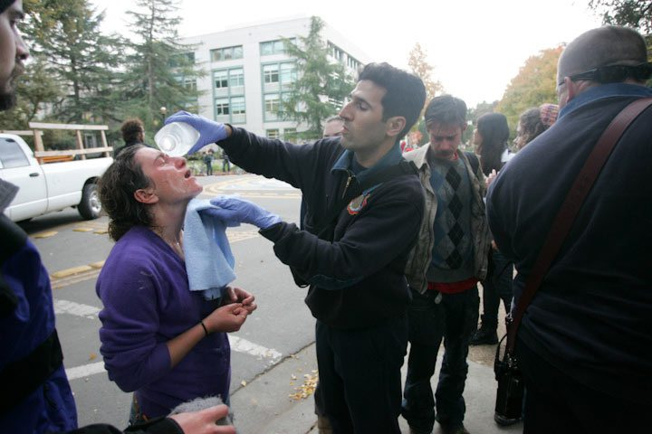
Document 8:
XJ: So, we see in the videos and photos that you were one of the students pepper-sprayed by Lieutenant John Pike yesterday. How are you doing today?
W: I still have a burning sensation in my throat, lips and nose, especially when I start coughing, or when I'm lying in bed. Everyone who got sprayed has sustained effects like this.

XJ: Can you tell us how it happened, from where you were sitting?

W: I'd pulled my beanie hat over my eyes, to protect my eyes. I received a lot of pepper spray in my throat. I vomited twice, right away, then spent the next hour or two dry heaving. Someone said they saw him spray down my throat intentionally, but I was so freaked out, and I was blinded by my hat, so I can't verify. I did get a large quantity of pepper spray in my lungs. Another girl near me who has asthma had an attack triggered by the pepper spray, and she was taken to the hospital.

He used military grade pepper spray on us. It's supposed to be used at a minimum of 15 feet. But he sprayed us at point blank range. Another student, 20 years old, who was sprayed and then arrested—instead of receiving medical care for the pepper spray exposure, he was made to wait in the back of a police car. His hands were sprayed, and he had intense burning in his hands throughout the evening while he was being held.

Source: http://boingboing.net/2011/11/20/ucdeyetwitness.html

