Unit 7, Day 2 – Cultural Geography of Europe and Russia

Bell Ringer: Answer the following test prep questions.

1. Which of the following describes the population distribution in Russia?
A. The population is the highest in Northern Russia and Southeast Russia
B. The population is extremely low everywhere in Russia except in the very northern part
C. The population is extremely low throughout most of Russia, except near the European border
D. The population is extremely high in Southeast Russia

2. Which of the following describes the climates of Europe?
A. There are mostly tundra and subarctic climates
B. There are mostly humid subtropical and humid continental climates
C. There is mostly a desert and steppe climate
D. The main climates are Marine West Coast, Mediterranean, and Humid Subtropical

3. Throughout history many people have moved to European cities because
A. They are all along the coast
B. They have arid climates
C. They have arable land
D. They have extreme climates

Notes:

- Throughout Europe, most people are __________________________
  - Three main branches of Christianity are Catholicism, Protestantism, and _____________________
  - Massive reduction of other religions after ______________________
- Ethnic groups and _____________________ are specific to each ______________________
- Most languages come from the same language _____________________, but have changed over time
- ________________ Treaty set up the European Union
  - The European Union got rid of ______________________ on the movement of goods, services, and people across country borders in Europe.
  - It established a single European _____________________, central ______________, and common foreign policy.
- ___________________ Europe used to be the communist Soviet Union before World War II.
- Frequent battles and occupations during WWII caused ________________________, or the hostile division of a region into __________________ ______________________.
- Three main ethnic groups in Russia
  - Slavs: dominate Russia’s politics and culture
  - Caucasian people: large group in Russia, called Caucasian because they live in the __________________________ region of Southwest Russia.
  - _______________ People: smaller ethnic group that lives in Southwest Russia.

Practice:
- Given what you know about language and ethnic groups in Europe, in which country would you expect a French speaking person to live?
- Switzerland B. France C. Germany D. Spain

- Trade and travel are made easy from one European country to the next because of the:
- Foreign policy B. Common language C. European Union D. Rugged landscape

- Languages in European countries
- Are the same in each country B. Come from the same language family C. Have no similarities
D. All of the above

Eurotrip Travel Journal
Congratulations! You have been selected to go on a free trip throughout Europe and Russia! During your trip you will visit museums, eat local food, do outdoor activities, go shopping, and mingle with the locals. When you get back from your Eurotrip, you will want to be able to brag about your awesome trip to all of your friends and family.

Step 1: Choose and circle 3 European cities from the list below.
Paris, France
Amsterdam, Netherlands
Berlin, Germany
Madrid, Spain
Barcelona, Spain
Moscow, Russia
London, England
Prague, Czech Republic
Dublin, Ireland
St. Petersburg, Russia
Rome, Italy
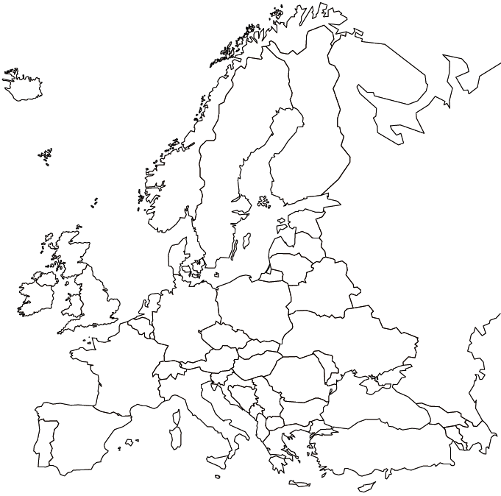
Venice, Italy
Athens, Greece
Budapest, Hungary

Step 2: Mark your 3 cities on the map.

Step 3: Research the cities that you chose and fill in the chart below. Make sure to write the names of your cities next to City 1, City 2, and City 3.
 | City 1 | City 2 | City 3
Climate/ typical weather
5 Major attractions / sightseeing i.e. museums, markets, shopping, historical sites, monuments, buildings, etc.
Local food
Best hotel
Airport name
Language Spoken
City population
Anything else you would like to do/ see in this city

Step 4: Create a travel journal that you can use when you get back from your trip to share with your friends and family. You should have at least two journal entries for each city that you visit. You should be as specific as possible and you should include information from the chart that you filled out. You can include pictures, maps, timelines, stamps, or anything else that you want to make your journal as realistic as possible.

