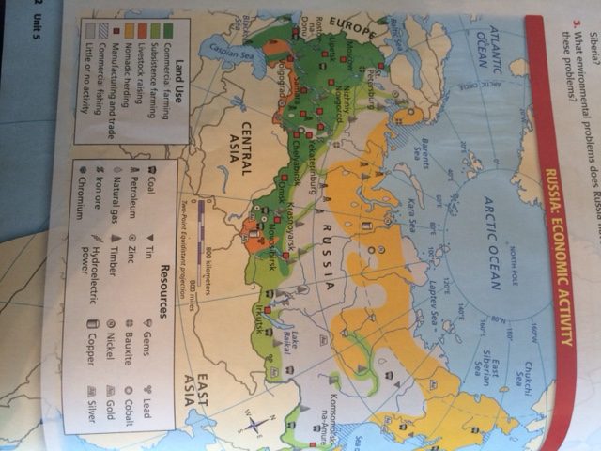**Document 1 –** Natural Resource Map of Russia

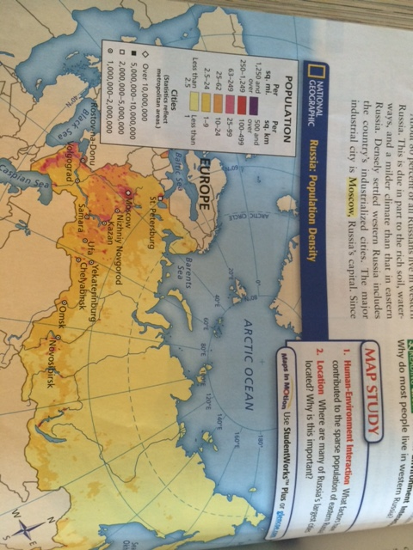**Document 2-** Population Density map of Russia

**Document 3**-Population Density Map of Europe

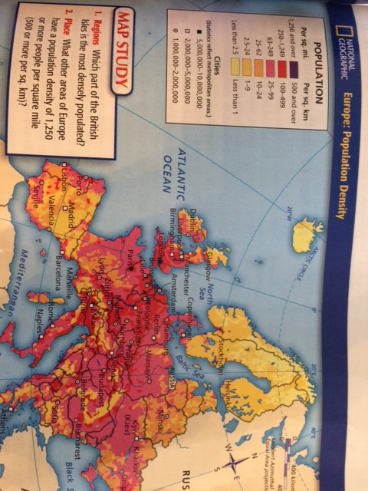

**Document 4-** Climate Map of Europe

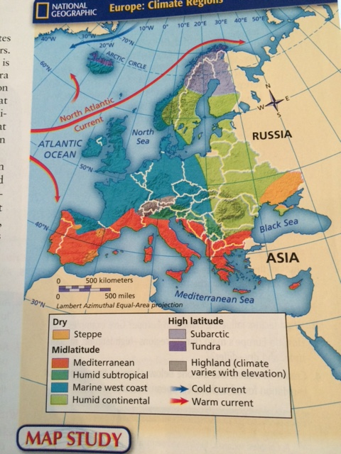

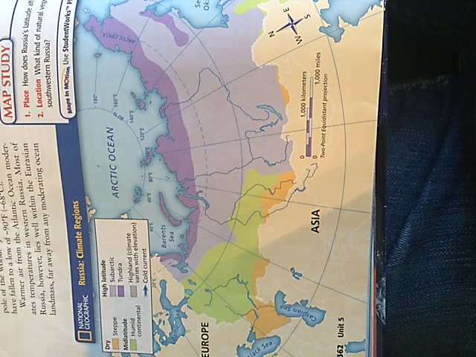**Document 5­** – Climate Map of Russia

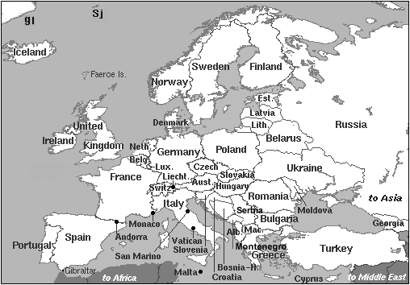**Reference Map**