Unit 7, Day 1: Physical Geography of Europe and Russia
Video Guide
1. What landform separates Europe and Asia? ___________________________
2. Russia is on two continents. ____________________ and ___________________.
3. The population density is high in Europe because the land is ____________________ and the climate is ___________.
4. The major rivers provide transportation and _____________________.
5. ___________________ block the cold winds from entering Southern Europe, creating a humid subtropical climate.
6. Russia is different from the rest of Europe because they have many natural ____________________.

Physical Geography Notes: As we go through the slides, write down the name of the landform or body of water and put the number next to description where it is on your map.
DESCRIPTION | LANDFORM/BODY OF WATER
1. A Mountain system that forms a crescent from southern France to the Balkan Peninsula. Highest peak is 15,771 ft.
2. The sea in between the British Isles and Northern Europe.
3. A river that extends from Germany’s Black Forest to the Black Sea
4. Islands in Northern Europe that make up the United Kingdom
5. Flat fertile lands stretching across Northern Europe. They have deposits of natural resources in this area
6. A sea that is in between Southern Europe and Africa
7. A sea that is in between Greece and Turkey
8. A sea in Eastern Europe, just West of Russia
9. An ocean along the west coast of Europe
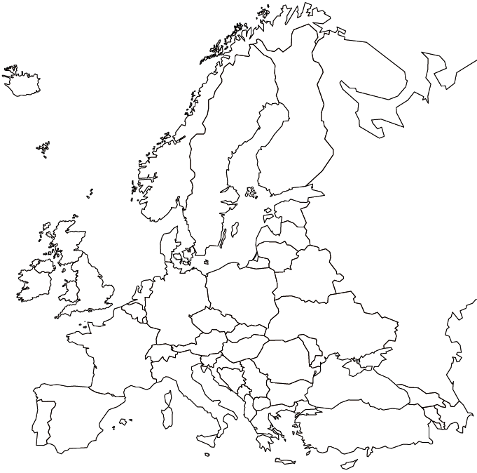

Map Work- use pg. 270- 8 minutes
Directions: Label the following countries on the map.
France, Portugal, Spain, Italy, Germany, United Kingdom, Greece, Sweden, Norway, Poland

Map Document Based Questions – 15 minutes
Directions: Use the documents in the folder to answer the questions below.

1. According to document 2, is the population density high or low in Russia? __________________________
2. According to document 2, is the population density generally high or low in Europe? __________________
3. According to documents 2 & 5, describe how the climate affects the population density in Russia. ________________________________________________________________________________________________________________________________________________________________________________________________________________________________________________________________________________________________________________________________________________________________________________________________________

4. According to documents 3 & 4, describe how the climate affects the population density in Europe.
________________________________________________________________________________________________________________________________________________________________________________________________________________________________________________________________________________________________________________________________________________________________________________________________________

5. According to Document 1, which region of Russia has the most farming?
A. Northeast Russia B. Central Russia C. Southwest Russia D. Northwest Russia

6. Why do you think the population density is low in the area surrounding Madrid, Spain? ______________________________________________________________________________________________________________________________________________________________________________________________________________________________________________________________________________________________________

