Name:________________________ Date:________
Executive Branch Day 1

Bell Ringer
Answer the 2 test prep questions below using the political cartoon.
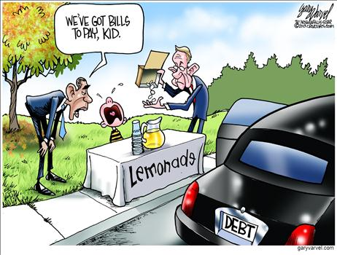
1. Which word most accurately describes the government according to the political cartoon?
A. Helpful
B. Irresponsible
C. Inspirational
D. Generous

2. Why are the men visiting the lemonade stand?
A. They wanted to buy lemonade
B. They want to give the boy money
C. They want to take the boy’s money to help the government
D. They want to close down his lemonade stand

Today’s Objective
____________________________________________________________________________________________________________________________________________________________________________________________________

Qualities of the President

List 3 qualities that you think the President must have

Constitutional Qualifications of the President
QUALIFICATION
AGE
CITIZENSHIP
RESIDENCE

Do these qualifications ensure a good president? Should the qualifications be stricter? Why or why not?
__________________________________________________________________________________________________________________________________________________________________________________________________________________________________________________________________________________________________________________________________________________________________________________________________________________________________________________________________
Presidential Biographies
Directions: Choose 1 president from your group’s folder and fill out the form below about your president.

My President Is:________________________

- What years was he President?_______________________________________________
- What state is he from?_____________________________________

- What political positions did he have before being President?
_________________________________________________________________________________________________________________________________________________________________________________________________________________________________________________________

4. Did he have any jobs outside of politics before President? What were they?
_________________________________________________________________________________________________________________________________________________________________________________________________________________________________________________________

5. What political party was he?_______________________________________________

6. Did he have a formal education? If so, where did he attend school?
_________________________________________________________________________________________________________________________________________________________________________________________________________________________________________________________

7. Did he have any published writing? Why does this matter?
______________________________________________________________________________________________________________________________________________________________________

8. Describe his family life. Did he have a wife & kids? Why does this matter?
________________________________________________________________________________________________________________________________________________________________________________________________________________________________________________________

9. What is something unique about this President?
______________________________________________________________________________________________________________________________________________________________________

10. Describe his appearance. What does he tend to wear? Does he look like he is in shape?
___________________________________________________________________________________________________________________________________________________________________________________________________________________________________________________________________________________________________________________________________________

