AP Human Geography

Unit 3, Day 1

|  |  |  |
| --- | --- | --- |
|  | **Habit** | **Custom** |
| Description |  |  |
| Example |  |  |
| Example from your life: |  |  |

|  |  |  |
| --- | --- | --- |
|  | **Folk Culture** | **Popular Culture** |
| Definitions |  |  |
| Origins |  |  |
| Diffusion |  |  |
| Distribution |  |  |
| Music |  |  |
| Sports |  |  |

Folk Vs. Popular Culture

**Folk Art Example**: Different religious groups in the area (Hindus, Muslims, Animists, and Buddhists) have different types of art that depict the Himalaya Mountains based on their specific belief about art and religious traditions.

**Example of Popular Culture Diffusion: Fashion Trends**

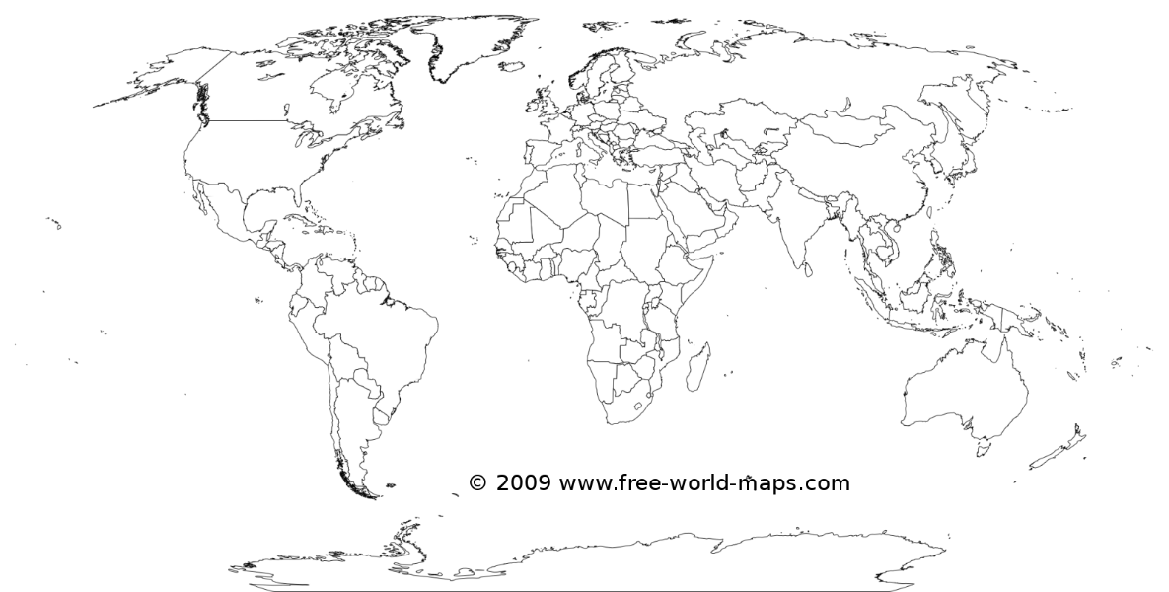

1. Show where the hearths of popular fashion are.

2. Write out the process of diffusion. Where might the fashion trends diffuse first? Draw a timeline with arrows below to show the diffusion.

**Example of Local Folk Culture: Amish People. Video Case Study**

**3. Identify Amish core areas (larger settlements) and then use dots and arrows to indicate the spread of Amish culture throughout a larger region.**



