Name:________________________ Date:________
Origins of Agriculture
Review Bell Ringer

- For many years, French Canadians from Quebec sought _____, or the right to govern themselves and establish their own independent state.
- Dominance
- Imperialism
- Colonialism
- Federalism
- Territorialism
- When one country exerts political, economic, or social influence over another without the aid of official government institutions it is called
- Dominance
- Imperialism
- Colonialism
- Federalism
- Territorialism
- __________________ boundaries characterize much of Africa as they ignore cultural and tribal differences across space.
- Superimposed
- Subsequent
- Colonial
- Antecedent
- Territorial
- With its system of regional provinces, Canada is an example of a
- Microstate
- Electoral state
- Reapportioned state
- Federal state
- Nation-state
- Which of the following is a landlocked country?
- Peru
- Germany
- Burma
- Afghanistan
- Colombia

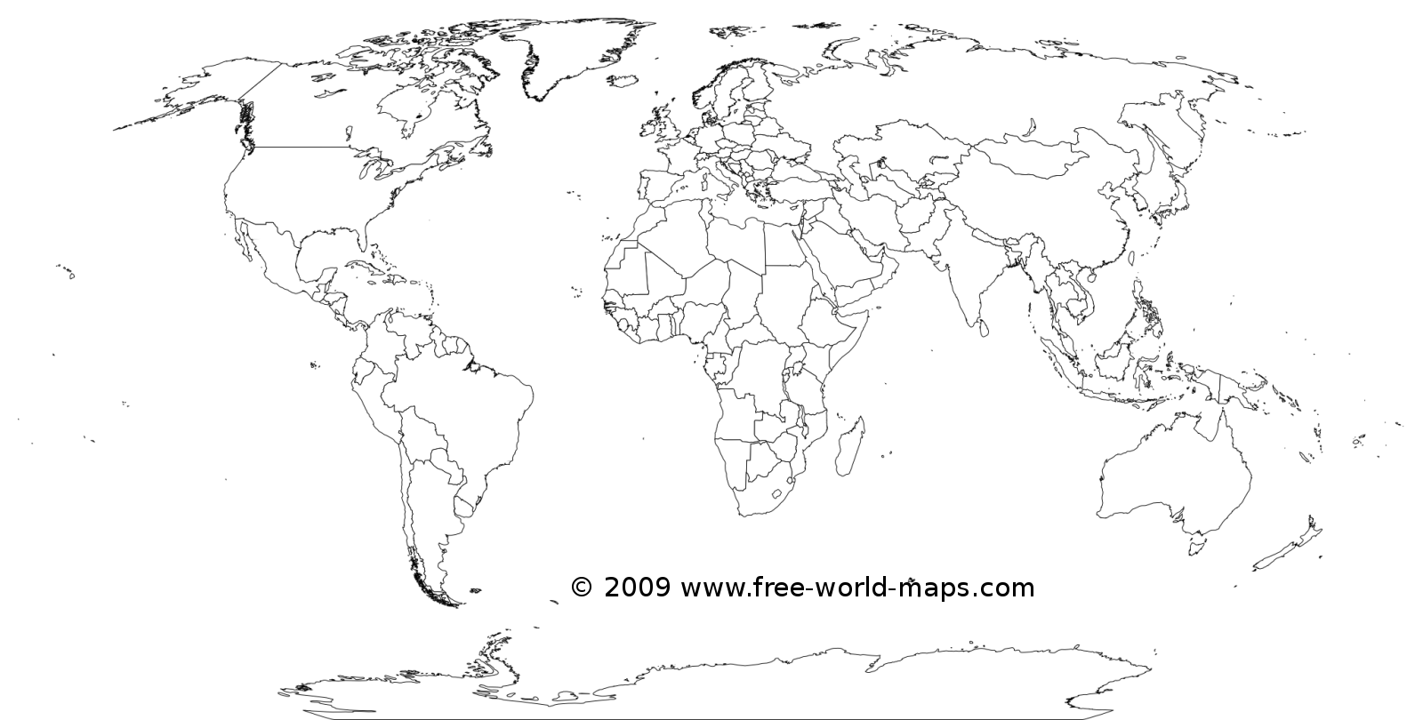
Geo-located Notes: Agricultural Hearths

 | 1st Agricultural Revolution | 2nd Agricultural Revolution | 3rd Agricultural Revolution/ Green Revolution
Dates
New Developments
Other notable effects
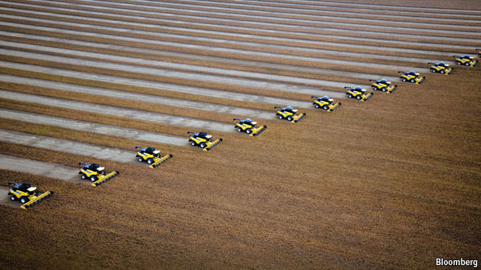
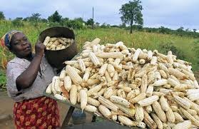

Agricultural Revolutions

