Name:__________________
Date:___________________
AP Human Geography
Class #4 Activities

I. Time Zones and Globe terms
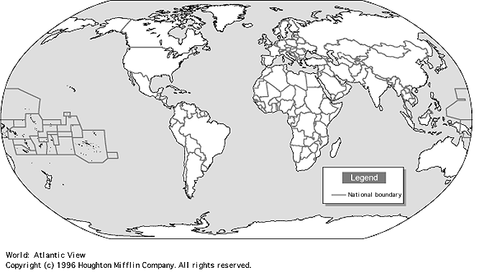
II. Notes
- Geographic Information System (GIS) A computerized system that captures, stores, analyzes, and displays geographic data. It can be used to produce maps. Information can be produced in layers and those layers can be compared to show relationships among different kinds of information.
- Global Positioning System (GPS) Mostly used for navigation but can also be used to find a precise location.
-Satellites placed in space
-Tracking stations exist to monitor and control satellites
-A receiver that can locate satellites
Tobler’s First Law
Key 2 Components
Formula
Explanation in your own words
Time Distance Decay

Example: | Main City:_______________________  Population:______________________  City 2:_________________________  Population:_____________________  Distance from main city:_____________________  City 3:_________________________  Population:_____________________  Distance from main city:_____________________  Does city 2 or 3 have a stronger gravity toward the main city?__________________  Image:  