Unit 4 North Africa and Southwest Asia (The Middle East) Day 1
Bell Ringer: Look at the picture on the board and answer the questions in the chart below. 5 minutes
Describe the climate of this place. Is it hot, warm, dry, wet, arid, semiarid, tropical etc? How can you tell? Provide evidence from the photo.
Describe the vegetation of this place. Is there a lot of vegetation? Is there little? How can you tell? Provide evidence from the photo.
Do you think there is a high or low population density in the place in the photo? How can you tell?
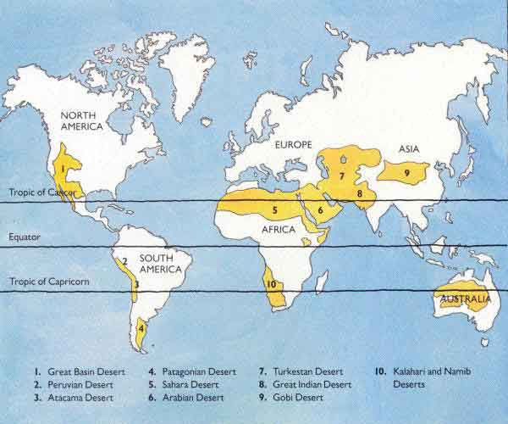
WAIT FOR DIRECTIONS
Level 1: WHAT? What is this map showing us?
Level 2: WHERE? Where are most of the deserts in the world?
Level 3: WHY THERE? Why are most of the deserts located there?
Level 4: SO WHAT? How do these deserts impact this region? (think about population density, vegetation, drought, health)

4-level map analysis (10 minutes) - Look at the map to the right and answer the questions in the 4 level map analysis chart below.

1. Label the major countries that make up the Middle East
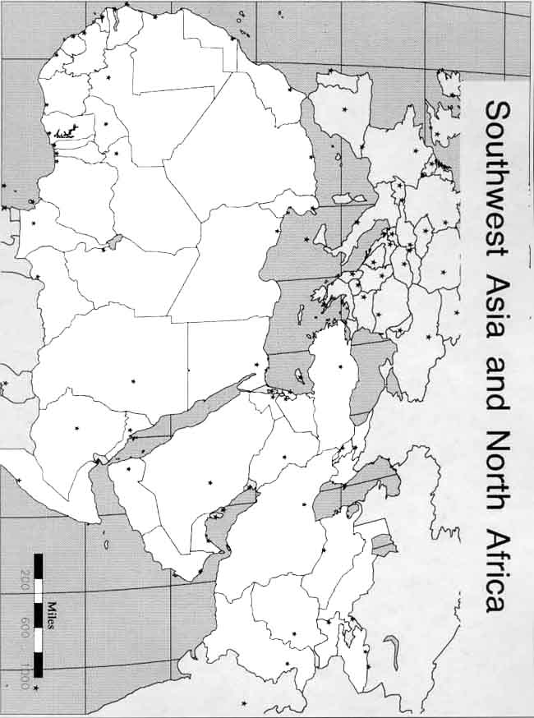
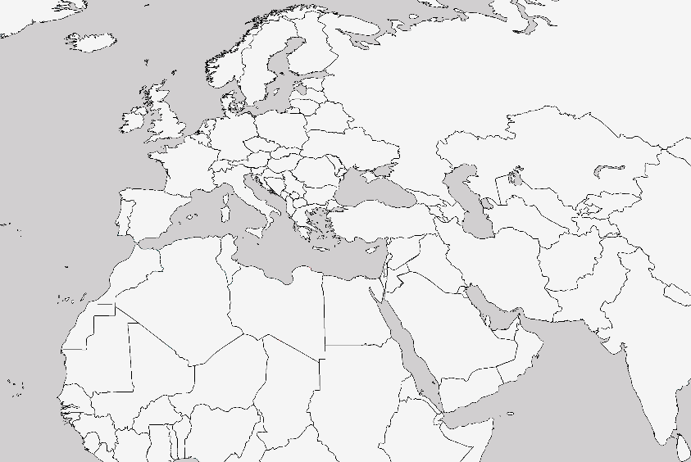

3. Map annotation- Annotate the map like the one on the board.

4. How do you think the climate, landforms, and bodies of water affect this region?_________________________________________________________________________________________________________________________________________________________________________________________________________________________________________________________________________________________________________________________________________________________________________________________________________________________________________

Exit Ticket:
- The main climate of North Africa / Southwest Asia is:
- Steppe
- Tropical Wet
- Humid Subtropical
- Arctic
2. The Nile River is an important body of water because
A. It is a source of freshwater in this mostly desert region
B. It is the main source of fishing in the world
C. It stretches through the entire continent of Africa
D. It is the second largest river in the world.
3. The Dead Sea is unique because
A. it is dangerous and if people go in it they will die
B. It is where ancient tribes used to dispose of dead bodies
C. It is going through eutrophication
D. It is the lowest point on the earth, extremely salty, and no organism can live there.
4. Compared to the rest of the world, the Middle East has the greatest number of _________________
A. Deserts
B. Glaciers
C. Mountains
D. Plateaus

