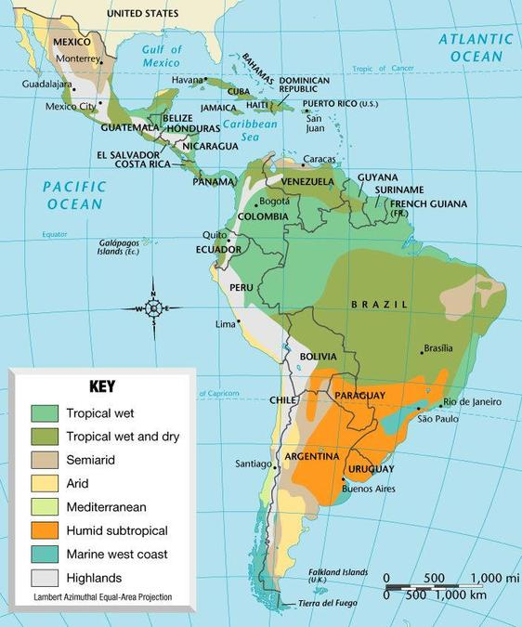
3. Latin America 4 level climate map analysis

Level 1 WHAT: What does this map show? Are there many climates? Are there few? Are they mostly warm/cold/wet/dry?
Level 2 WHERE: Of where is this map? What areas have the wettest climates? What areas have the driest climates? What areas have many climates?
Level 3 WHY THERE? Which climates do you see? Why are there many or few climates? Why are some climates in certain places?
Level 4 SO WHAT? How could this impact Latin America’s vegetation, culture, and environment?

4. Natural Disasters: Fill this information out on your own (4 minutes)
a. List 3 kinds of natural disasters
1.
2.
3.
b. Why does Latin America have more natural disasters happen than other parts of the world? ______________________________________________________________________________________________________________________________________________________________________________________________________________________________________________________________________________________________________
c. List 3 negative effects of a natural disaster:
1.
2.
3.
9/15/14- Climate of Latin America
1. Bell Ringer: Below, write a paragraph (or more) from the perspective of someone who is present during an earthquake (5 minutes)
________________________________________________________________________________________________________________________________________________________________________________________________________________________________________________________________________________________________________________________________________________________________________________________________________________________________________________________________________________________________________________________________________________________________________________________________________________________________________________________________________________________________________________________________________________________________________________________________________________________________________________________________________________________________________________________________________________________________________________________________________________________________________________________________________________________________________________________________________________________________________________________________________________________

2. KWL about the 2010 earthquake in Haiti: With your tables, fill in the first two columns of your KWL Chart about the Earthquake in Haiti (4 minutes). At least 4 bullets in each box.
WHAT I KNOW (before the lesson) | WHAT I WANT TO KNOW (before the lesson) | WHAT I LEARNED (after the lesson)

