Name:_______________________________
Directions: Create a citizen of any kind. They can be a productive citizen or not a productive citizen. Make sure that you draw some
kinds of symbols on the person to represent what you mean
OR write a 5 sentence biography about the person. Draw symbols
and write captions on the sides.
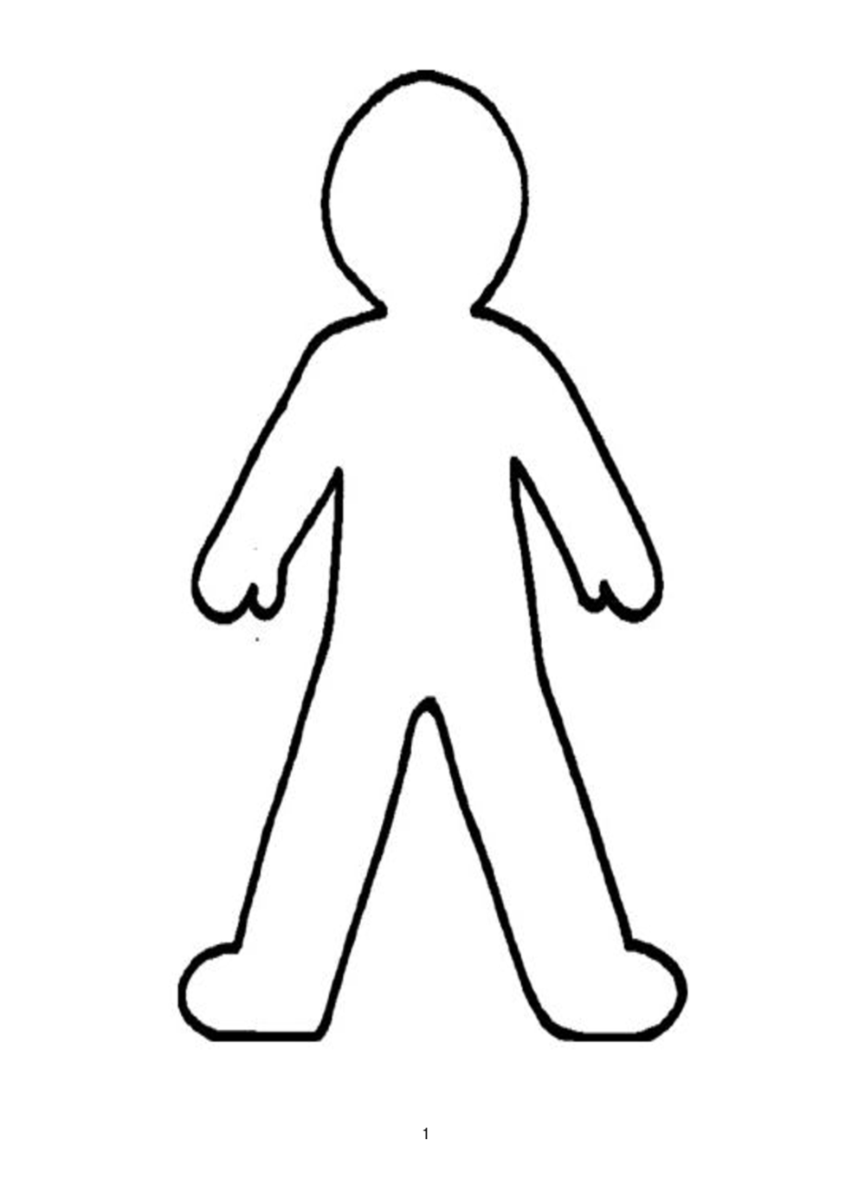

Name:_______________________________
Directions: Create a citizen of any kind. They can be a productive citizen or not a productive citizen. Make sure that you draw some
kinds of symbols on the person to represent what you mean
OR write a 5 sentence biography about the person. Draw symbols
and write captions on the sides.

