Peace Prize awarded to Malala Yousafzai and Kailash Satyarthi

The Nobel Peace Prize
Malala Yousafzai won the Nobel Peace Prize on Friday. Malala is a teenage girl who was shot by religious fighters. She had stood up against laws that stopped girls from getting an education in Pakistan.
She shared the important award with Indian children’s rights supporter Kailash Satyarthi.
Malala is 17 years old. Satyarthi is 60. Malala has become a symbol of hope in Pakistan. Girls there are sometimes killed by their own families if they dare to marry for love. They are also kept out of school in some communities.

A Pakistani And An Indian
The award comes as girls are under attack in other countries.
In Nigeria, hundreds of schoolgirls have been kidnapped by the violent group Boko Haram. They are still being held. In India, two girls were killed in a village in May.
“This award is for all the children who are voiceless, whose voices need to be heard,” Malala said. She was the youngest person in history to receive the Peace Prize. Satyarthi, the other winner, started the Save the Childhood Movement. The group has worked to free thousands of children from being sold as slaves or forced to work.The decision was very meaningful. The award was shared by a Pakistani and an Indian. Each struggled for children’s rights. The countries they represent are neighbors, but not friendly ones. They have fought several wars against each other. In the past few days bombings have happened on the border between the two countries.

Nearly Killed By Taliban
Malala is a high school student. After she was shot by the Taliban, she moved to England for medical treatment. She was in school when the prize was announced. Malala made the world wait until after school for her comments.“This is not the end. … I want to see every child going to school and getting an education,” she said. When she was 11, Malala spoke out against a rule by the religious group the Taliban. The group said that girls could not be educated. Malala wrote a blog supporting girls’ education. She also appeared on TV and in a movie. In October 2012, she was riding on a school bus in Pakistan. Taliban men with guns got on board. They asked for her by name and opened fire. A bullet to the head nearly killed her.
Malala has impressed people with her ideas of forgiveness and peace. Her comments to the United Nations last year showed her hope for something better for girls. She said the shooting changed her: "Weakness, fear and hopelessness died. Strength, power and courage was born."

"Start Speaking For Their Rights"
Shah Jan works for the Human Rights Commission of Pakistan. Jan said that Malala had helped girls get an education in Pakistan. But some girls there are still forced to marry at early ages. Others are abused or killed.

“It will take time for the girls inspired by Malala to become educated and start speaking for their rights,” Jan said. Malala escaped a tough life in Pakistan. For millions of other girls, life is still like a prison.
She said that she didn't want her future to be just sitting at home, cooking and having babies. “I didn’t want to see my life in that way,” she said last year.
1. Read and annotate the article by doing the following:
a. Write the main idea of each section
b. Underline information about Malala
C. Circle information that surprised you

2. In your own words describe why Malala got shot and who shot her. What is Malala fighting for In Pakistan and why? _______________________________________________________________________________________________

__________________________________________________________________________________________________

__________________________________________________________________________________________________

__________________________________________________________________________________________________

__________________________________________________________________________________________________

__________________________________________________________________________________________________

__________________________________________________________________________________________________

3. Where is Malala from? ____________________________________ Shade it in on the map below.

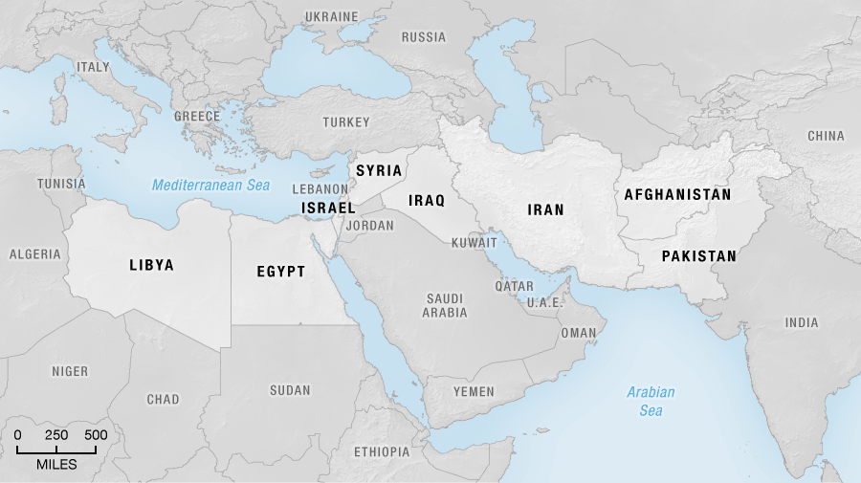

4. Personal reflection. Consider the following questions: What do you think about Malala’s story? Is she a hero? What do you think about her? Could you ever be like her? How would you do this?

__________________________________________________________________________________________________

__________________________________________________________________________________________________

__________________________________________________________________________________________________

__________________________________________________________________________________________________

__________________________________________________________________________________________________

