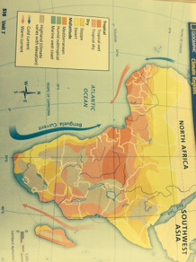
Sub Saharan Africa Climate Map (pg. 516)
(Document 1)

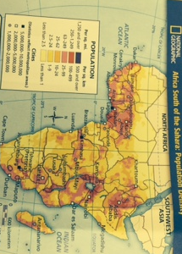
Sub Saharan Africa Population Density Map pg. 530
(Document 2)

Sub Saharan Africa Desertification Map (pg. 502)
(Document 3)
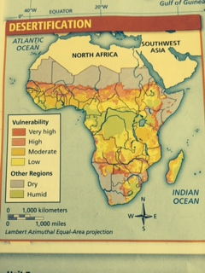

Sub Saharan Africa Ebola Map
(Document 4)

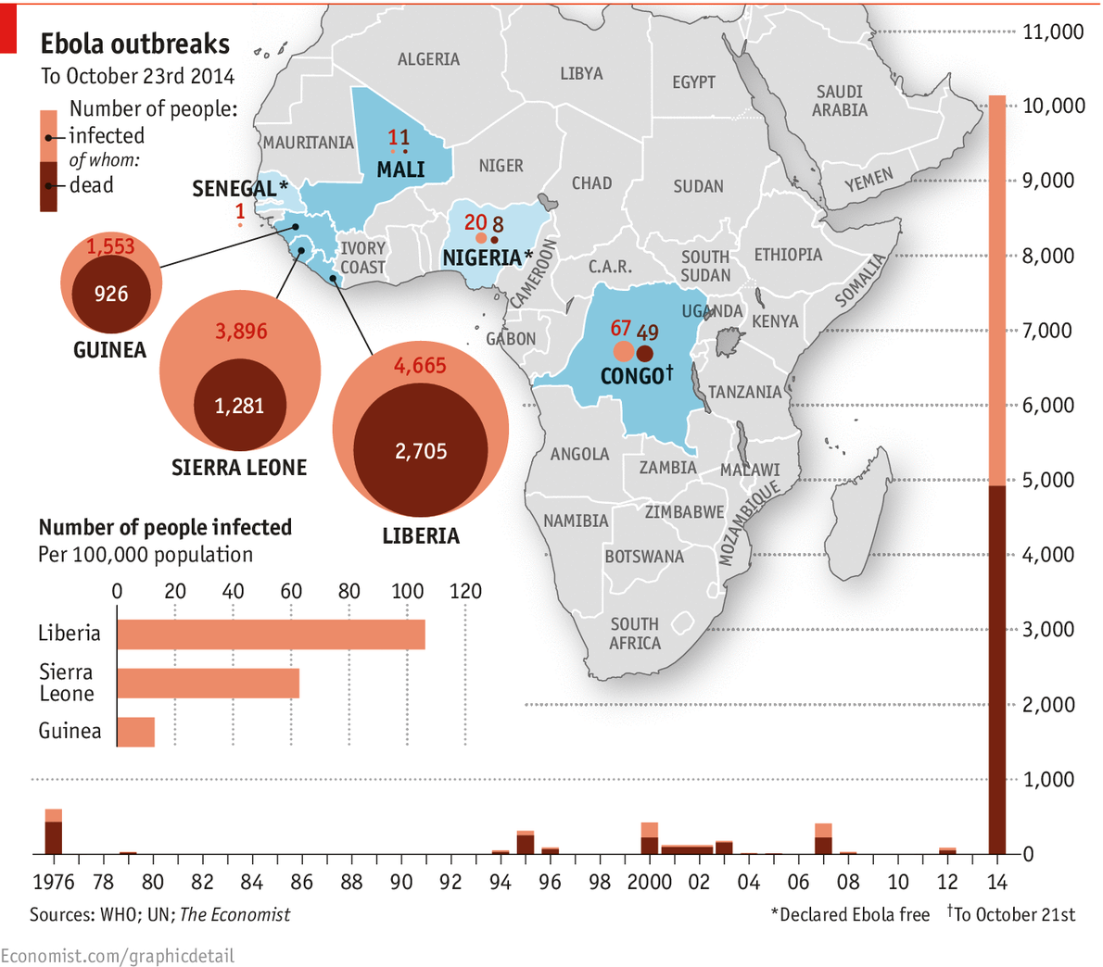

West Africa Deaths per Day
(Document 5)

