Name:__________________________ Date:______________
American Government Mid-Term Review Guide

Bell Ringer: Use the political cartoons to answer the questions.
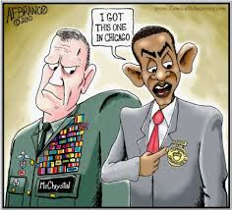
1. The political cartoon on the left describes President Obama as a(n) _____________________________ Commander in Chief.
A. effective
B. Unqualified
C. Brilliant
D. Outstanding

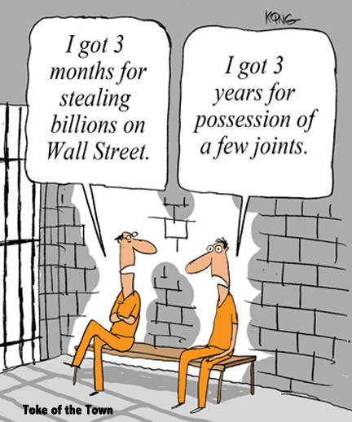
2. According to the political cartoon
A. our criminal justice system treats all fairly.
B. our criminal justice system places more severe consequences on crimes related to drugs than “white collar” crimes.
C. our criminal justice system has “gone soft” when it comes to punishment for drug use.
D. our prisons are too overcrowded.

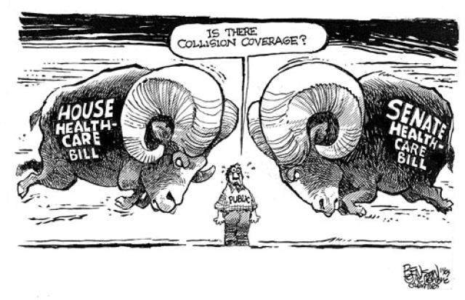
3. The principle of government shown in the political cartoon is:
A. Bicameralism
B. Democracy
C. Social Contract Theory
D. Federalism

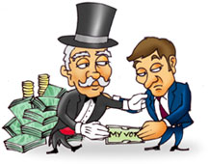
4. The man on the left (in the top hat) is most likely:
A. The President
B. A congressman
C. A lobbyist
D. A Supreme Court Justice

Fill in the Blanks Review
Directions: Fill in the blanks using the words above. Words will only be used once.

I. The Judicial Branch
Appeals, President, Unconstitutional, 9, District, Certiorari, Felony, Civil, Miranda, Activism, Marbury Vs. Madison, Judicial Review

1. The Supreme Court has ______ members.

2. The Court of _________________, has appellate jurisdiction, meaning that it only hears cases that have been heard before.

3. Most of the work of the federal courts happens in the ________ courts.

4. Supreme Court justices are appointed by the _____________________.

5. Only the Supreme Court has the power to declare laws or executive acts _________________________.

6. Writ of __________________ means that the Supreme Court can decide which cases they want to hear.

7. The rights that criminals are read as they are arrested are called _________________ rights.

8. The most severe crime is called a __________________.

9. __________________________ is the court case that established judicial review.

10. ______________________________ is the power of the Supreme Court to declare something unconstitutional.

11. A ______________________ case is when two people have a disagreement.

12. Judicial __________________ is when a justice is willing to change precedent.

II. The Legislative Branch

100, Congress, Laws, 435, War, Unlimited, 2, 6, Bill, Vice President, Lobbyists, joint-conference

1. The House of Representatives has ______ members.

2. The Senate has __________ members.

3. The _______________ is comprised of both the House and the Senate.

4. The legislative Branch’s main role is to make ___________.

5. The legislative branch has the sole power to declare _____________.

6. A proposed law is called a ___________.

7. Senators have terms that last for ________ years.

8. Members of the House of Representatives has terms that last for __________ years.

9. Members of the legislative branch can run for reelection an _____________ amount of times.

10. The people who represent interest groups and try to persuade members of congress are called ______________.

11. If the senate and house do not agree on a bill, they will form a ______________ - _______________________ committee with both houses of Congress.

12. The _______________________ is the leader of the Senate.

III. The Executive Branch

Natural born, 2, 35, Vice President, Sanction, War, Country, Commander in Chief, Politics, White House, 4, Economic Aid

1. The President lives in the _________________________.

2. The President serves for _____ years.

3. The President can only serve for _____ terms.

4. The President must be a _____________ citizen.

5. The President must be ___________ years old.

6. Most of our Presidents have had a past career in ______________________.

7. The President’s role that allows him to control our armed forces is ____________________________________.

8. An example of the President being Chief Diplomat would be him visiting another _________________.

9. The President can NOT declare ______________.

10. If the President dies or becomes ill, the ____________________ will become President.

11. A __________________ is a punishment or penalty on another country.

12. If a country has an earthquake or natural disaster, the United States might offer them

________________________________.

IV. Declaration of Independence and the philosophers.

John Locke, Thomas Hobbes, King George III, Montesquieu, Social Contract, Government, Constitution

1. __________________________’s belief in separation of powers led to the 3 branches of government.

2. _______________________ believed that human nature was very bad.

3. ________________________ believed that human nature was good.

4. All of the philosophers believed that ______________________ was necessary.

5. The Declaration of Independence is an example of the __________________________________ Theory.

6. The ________________________ maps out the rules and powers of our government.

7. The Declaration of Independence is a list of complaints to _______________________________.

Review Activities Choice Board
1. Draw a political cartoon on one of the following topics:  - Foreign policy  - Freedom of religion  - Miranda Rights  - Bail  - Discrimination in the criminal justice system | 2. Make a foldable of the 3 branches of government that has the following information:  Terms, qualifications, powers/roles, leader, # of members, & at least 3 funny #hashtags for each branch OR a pictures for each  i.e. #chiefofeverything | 3. Write a 1st person story from the perspective of someone going through the criminal justice process. Include all steps in the criminal justice process from the arrest to the appeals (pg. 594-595)
4. Complete vocab assignments for a HW grade.  - 10 (or more) vocab assignments from our calendars.  - Describe (IN YOUR OWN WORDS), draw, give an example, and use in a sentence | CHOICE BOARD: CHOOSE TWO REVIEW ACTIVITIES TO COMPLETE | 5. Criminal rights visual guide: Describe the rights of criminals in your own words and draw a picture to go along with it. Can be in a foldable, flashcards, list, or on the computer.  - remain silent, attorney, no unreasonable searches, fair bail, right to no cruel and unusual punishments, speedy trial
6. Article Reading and Questions:  Read the article on the round table about the Obamas and answer the questions on the back. | 7. Interest Groups Visual Guide:  Make a visual guide for the different types of interest groups. You can make a foldable, list, or flashcards. Include the type of interest group, a picture to show it, and an example of that kind of interest group.  - Business group, labor group, agricultural group, professional group, issue-oriented group, specific groups, religious organizations (248-252) | 8. How A Bill Becomes a Law  Make a board game that shows how bills become laws. You can structure it however you like as long as you make the actual board part of the game the steps for the law making process. (can be done in partners & can be the only activity completed today)
Choose (circle) 2 to complete during this class period.

