 | Judaism | Christianity | Islam
Followers Called
Number of followers worldwide
Worship Day of the Week
House of Worship
Year or Origin
Place of Origin
Holy City
Major Beliefs

Major Prophets/ Leaders
Holy Book

Symbol (name and draw)

Divisions within
(Denominations)

Monotheistic Religions of the World
Name___________________
Date:___________________

1. Bell Ringer: Respond to the following scenario in 4-6 sentences.
What would you do if one family member came into your room and said “this is my room now. Pack up your stuff and be out of here within the next two hours.” Would you leave? Would you stay? How would you resolve this conflict?

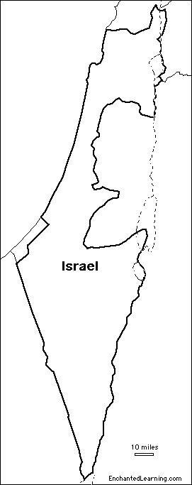
2. Map of Israel: Palestinian Vs. Israeli territory from 1946-2012

3. Video Guide: Answer the questions during the video
a. The Israeli Palestinian Conflict
List 2 important facts about Christianity
According to the video, what religion did Christianity come from?
List 2 important facts about Judaism
List 2 important facts about Islam

