AP Human Geography - Folk and Popular Culture Unit 3, Day 4 10/1/14
1. Bell Ringer: On the board are pictures of 6 McDonalds from 6 different continents (all except Antarctica). Below, fill in the boxes and try to determine which McDonalds is in each continent.

 | NORTH AMERICA | EUROPE | AFRICA | ASIA | AUSTRALIA | SOUTH AMERICA
Picture #
Evidence/ Rationale?

2. Notes: Diffusion of Popular Culture and Threats on Folk Culture
Key Term:
- Placelessness- the loss of uniqueness in a place.
- Example:

Diffusion of Popular Culture:
- Popular culture is spread __________________________
- The most common leisure activity in the United States is ___________________________

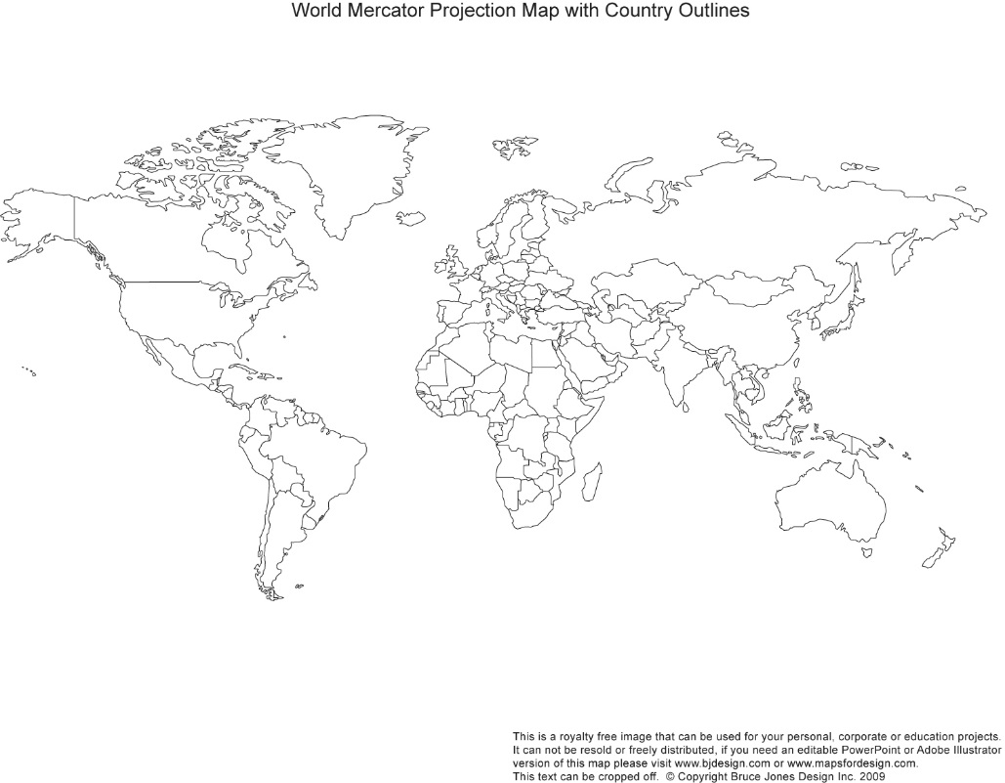
Diffusion of the Television:
- Early 20th Century- originates in the UK, France, Germany, Japan and Russia.
- Mid 20th Century-Diffuses to the United States, which had 86% of the world’s TV sets.
- Late 20th Century-Diffusion throughout Europe.
- Early 21st Century- Universal access to television.

Diffusion of the Internet:
- Describe how the internet has diffused over the past 5
years:__________________________________________________________________________________________________________________________________________________________________________________

Effects on Folk Culture:
- Internal Threat:_________________________________________________________________________________________________________________________________________________________________________________
- External Threat:_________________________________________________________________________________________________________________________________________________________________________________

Fighting Threats on Folk Culture:

Examples of Internet Countries: Looking at China, Iran, and North Korea.

Censorship Video Guide:

What is the opinion of the speaker in the video?
Describe China’s internet censorship:
Describe Iran’s Internet censorship:
Describe North Korea’s Internet censorship:

Why do these three countries have internet censorship?

