Unit 3 Day 2: The Middle East and Natural Resources
1. Bell Ringer: Look at the picture on the board and fill in the boxes below.

O | Object
P | Parts
T | Title or Words
I | Interrelationships
C | Conclusion
2. Notes
Oil and Water in the Middle East (ME)
- Do people live in the desert?
  - Yes, people __________ in the __________ of the Middle East.
- People live in the ME deserts because there is oil there.
- Oil = _______________
- Money will buy _____________, food, ________________, and anything else you want.
OPEC- Organization of the Petroleum Exporting Countries
- ______ of the world’s ____ is located in North Africa/ Southwest Asia
- Oil affects businesses, travel, exports, and us!
- Dramatically helps the ________________of the countries that produce & export oil
Water Crisis in the Middle East
- Bodies of water are __________ out
- People do not have _________________ that they _____________
- Growing _______________ means a growing ______________ for water
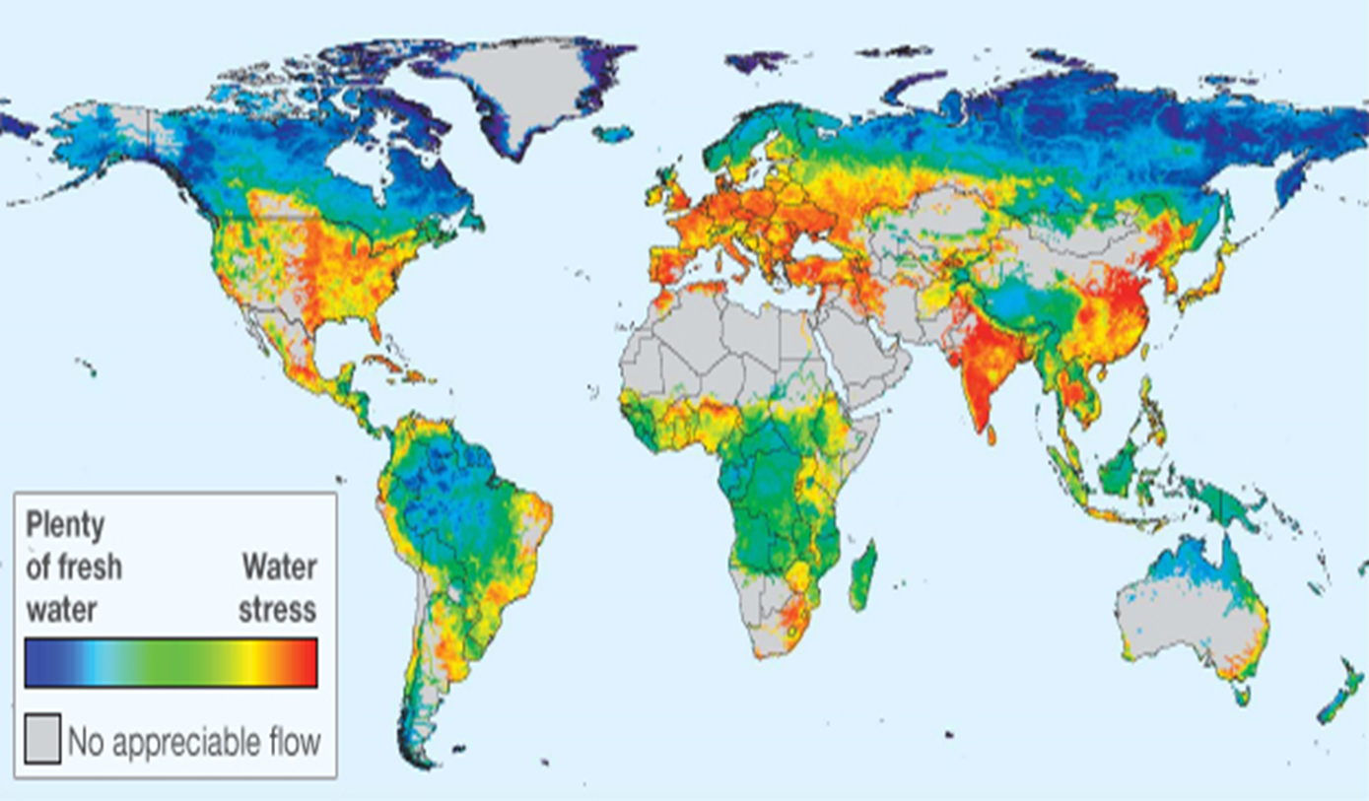
4 level map analysis – Use the map on the board (because it is in color) to fill in the following chart.

Level 1: WHAT is this map of?

Level 2: WHERE ARE THE EXTREMES? Where is there plenty of water and where is there no water?
Level 3: WHY THERE? Why do those places have a lot or no water?
Level 4: SO WHAT? How do these extremes impact those places?

How do the regions with “no appreciable flow” get the water that they need? After watching the video, explain the process of desalination and why it is important to the Middle East. ________________________________________________________________________________________________________________________________________________________________________________________________________________________________________________________________________________________________________________________________________________________________________________________________________

