PUT THESE PAPERS IN YOUR BINDER
1. Bell Ringer:
a. Shade in the US and Canada

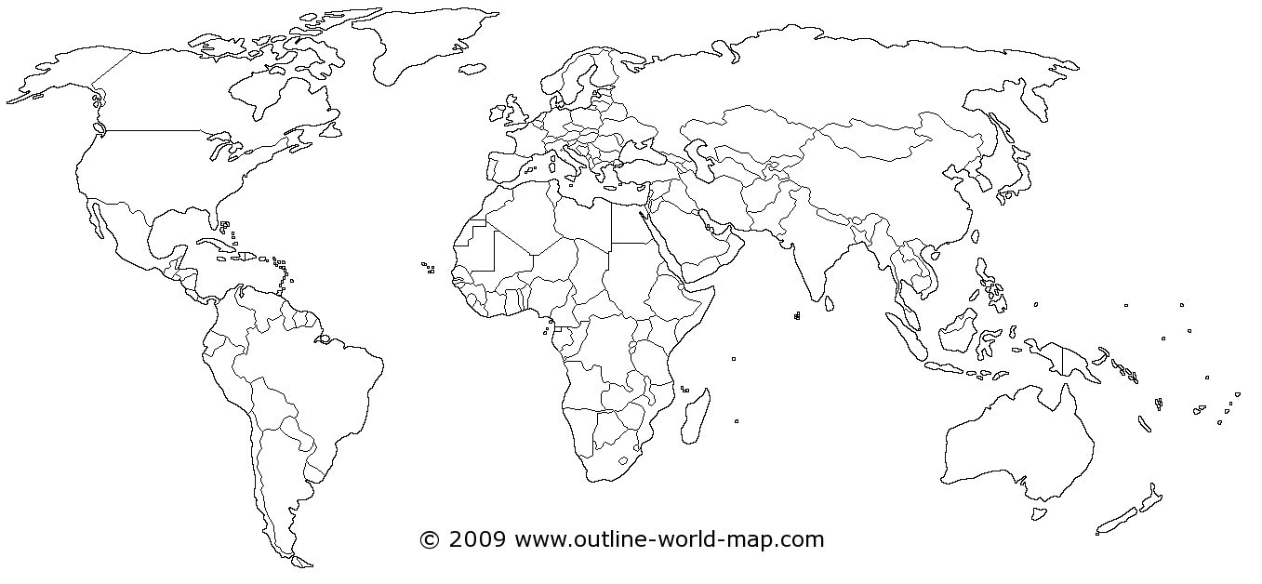

b. Label as many states as you can WITHOUT help from a map (abbreviations are fine)

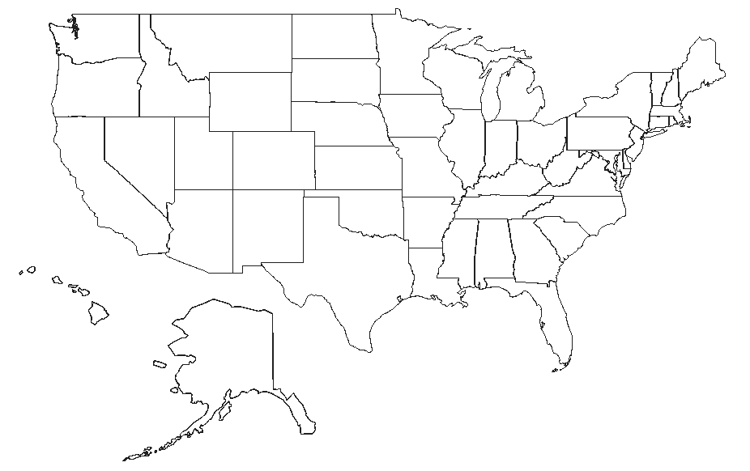
2. Map Notes: Annotate your map as we go through the important landforms and bodies of water on the Promethean board. YOU MUST COPY THIS PART FROM THE PURPLE BINDER!!!
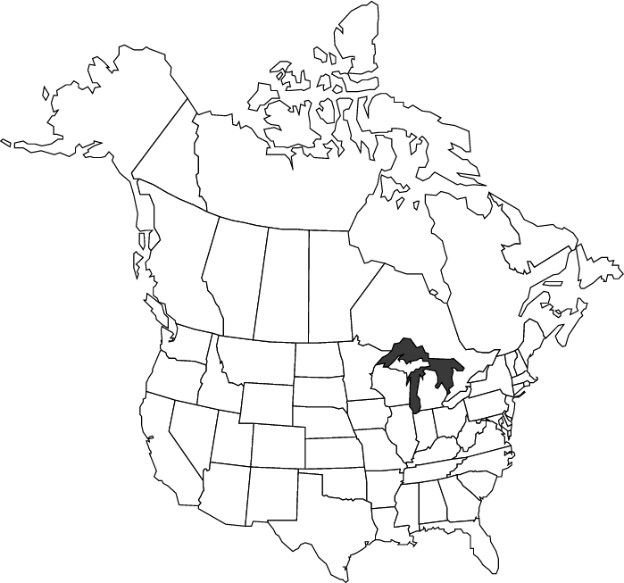
3. Georgia’s Physical Geography
a. DIRECTIONS: Code the reading below using the following codes. Whenever you read something about a LANDFORM write an L, whenever you read something about a BODY OF WATER, write a W.
L-Landforms
W- Waterway

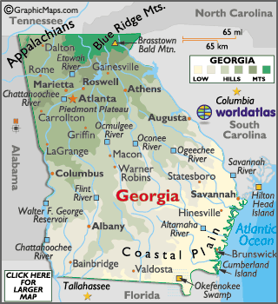
Northern Georgia is covered by the southern edges of the Appalachian Mountains. The heavily forested Blue Ridge Mountains, famed for a bluish color when seen from a distance, form the eastern front of the Appalachians, from Georgia to Pennsylvania. The state's highest point is located here; Brasstown Bald, at 4,784 ft.
The Appalachian Mountains, about 1,500 miles in length, extend through North Georgia, up through the New England states and on into the Canadian provinces of New Brunswick, Newfoundland and Quebec.
Moving south, the land lowers into the tobacco growing, rolling red-clay hills of the Piedmont Plateau, then continues to slope gradually south into the fertile lowlands of the coastal plain and the Atlantic Ocean coastline.
Stone Mountain, just east of Atlanta, is really not a mountain at all, but rather the largest single block of granite in the world. It's almost 6,000 ft. long and stands over 800 ft. tall. It is a major tourist attraction that depicts the confederate states.
Numerous sea islands, that attract beach loving tourists, front its deeply indented Atlantic Ocean coastline. Also in the south, scattered swampy areas are found, with the largest one being the Okefenokee Swamp along the border with Florida.
Georgia is drained by numerous rivers. Major ones include the Chattachoochee, Flint, Alamaha, Ocmulgee and Savannah. In addition, the state contains many manmade lakes and reservoirs including Lake Lanier, and Blue Ridge Lake.

b.DIRECTIONS: Label the 15 (total) most important bodies of water and landforms in Georgia and annotate 1 fact about each.
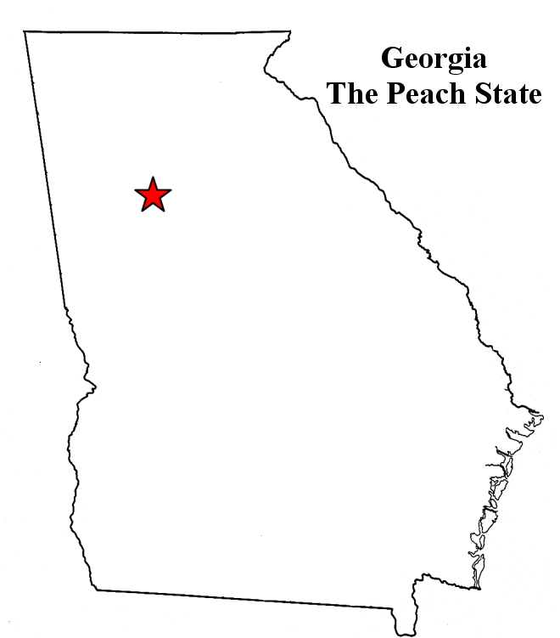
C. RAFT Write: On a piece of loose leaf paper, write 2-3 paragraphs using the following format:
Role- Travel journalist
Audience- Readers of Georgia Travel Magazine
Format- Magazine article
Topic- Pretend you work for a magazine and need to write an article that tries to get tourists to visit one physical geographic attraction in Georgia.

