Name:______________________________
Directions: Use the population density map below to answer the questions. This worksheet will be handed in.

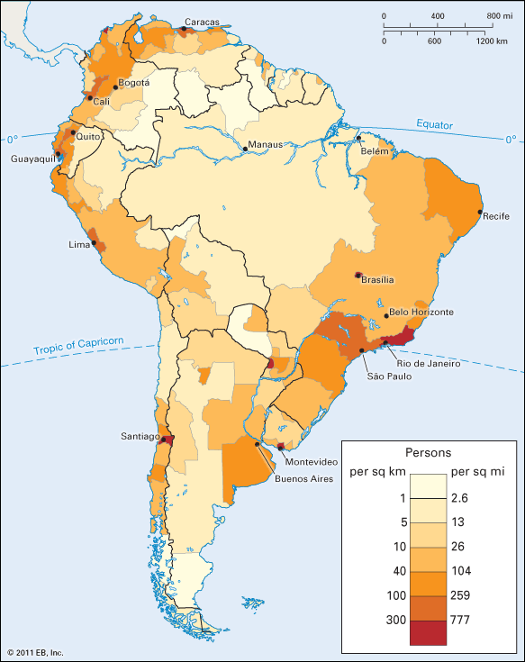
Population density of South America
1. Which color represents the MOST populated areas? _______________

2. Which color represents the LEAST populated areas?________________

3. Where are the most populated places? What do they have in common?______________________________________________________________________________________________________________________________________________________________________________________________________________________________

4. Where are the least populated places? What do they have in common?______________________________________________________________________________________________________________________________________________________________________________________________________________________________

5. What are some possible reasons for your answers to # 3 and 4? _________________________________________________________________________________________________________________________________________________________________________________________________________________________________________________________________________________________________________________________________________________________________________________________________________________________________________

6. Use the internet to find out what is in the center of the continent, which makes the population density so low. (The area with the river going through it). What is here and why does that make the population density low? USE YOUR OWN WORDS!!!
_________________________________________________________________________________________________________________________________________________________________________________________________________________________________________________________________________________________________________________________________________________________________________________________________________________________________________

