Unit 6, Day 2-Issues in Asia: Population and Natural Disasters
- Bell Ringer

a. Label the following on the map to the right:
- India
- China
- Gobi Desert
- Malay Archipelago
- Himalaya mountains

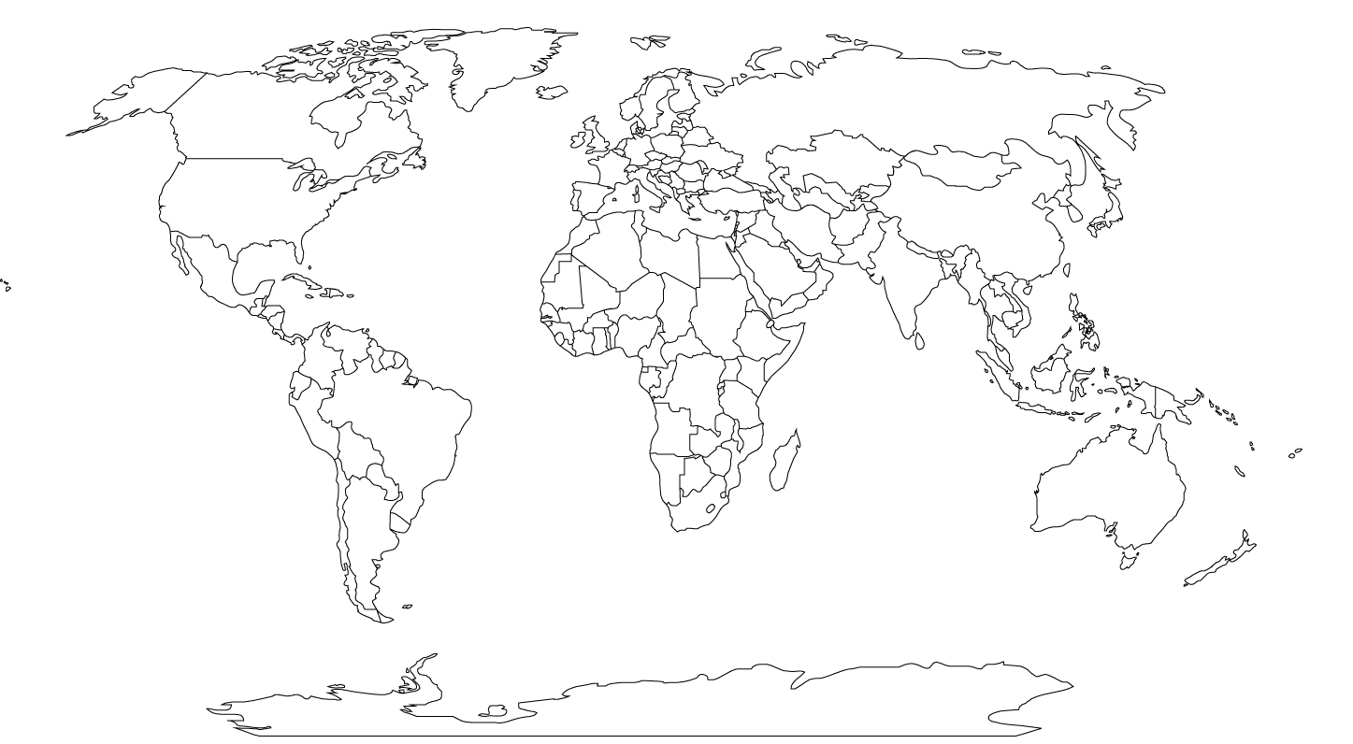
b. Shade in all of the regions of the world that we have studied so far.
Video 1 Notes Video 2 Notes
3. Notes
Fertility rate:
- population stays the same if the fertility rate is: ___________
India:
- _______ billion people (_______ of the world’s population)
- ½ country is ________ the age of _______
- _________ most_______________ country
- Fertility rate __________ children/woman
- Average _________ people per square mile
- Many extended families live together
Pakistan and Bangladesh :
- Became _____________________ countries because of ____________________ ethnic differences
- Bangladesh has ___________ people per square mile
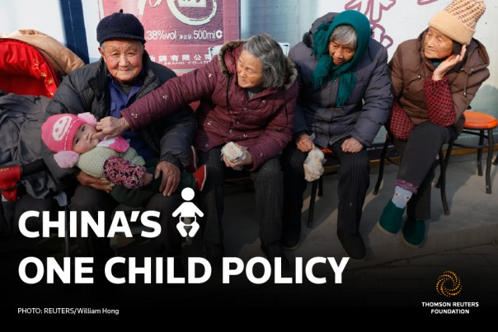
- ____________ population increases
- _______________________ increases lowers average birth rate
China:
- 1.4 __________________ people
- fertility rate _________ children/ woman
- World’s most populous country
- urbanization causes overcrowding in cities and not enough
___________________________________ in rural areas
- __________ child per family policy
One Child Policy:
- Causes ___________________(killing babies)
- Causes ____________________
- Highlights gender _____________________
Japan:
- __________ million people most live in urban areas along the coast
- Tokyo is the world’s most populous city (35 million people)

3. Practice Questions
- According to their birth rate of 1.4, the population in China is:
- Increasing
- Increasing rapidly
- Decreasing
- Staying the same

4. The One Child Policy might cause gender preference because:
A. families want girls instead of boys
B. families can choose the gender of their child
C. families want a boy instead of a girl
D. it does not cause gender preference
3. China has a lower population growth rate than India. This could be because:
A. People want to have fewer children
B. the One Child Policy stops population growth
C. China’s population growth is not lower than India
D. Children die more now than they used to

2. In India, half of the country is under the age of 25. This shows us:
A. the life expectancy is very high
B. there is a high infant mortality rate
C. There are more young people than elderly people
D. it does not show us anything

