Name:________________________Date:___________________Class Period:____________________
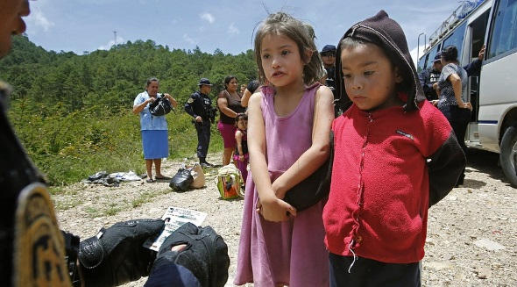
Directions: Read the article and do the following one at a time:
1. Write the main idea of each paragraph on this paper.
2. Circle reasons why children are leaving their homes in Latin America
3. Underline reasons why the United States should help them
4. Box reasons why the United States should not help them

PRO/CON: "Children's border crisis" Aug. 18, 2014
Most immigrants who cross into the U.S. without permission come through the border of Mexico. Now, more and more of them are children. Violence in Central America is growing worse. Children are gathering along the border to get away. Police at the border had spotted tattoos on some of them that made them seem like gang members. Others were stopped because of crimes in their home countries. A few had U.S. police records. The children told us stories of fleeing abuse at home, gangs and drugs.

Asking For Protection Here
U.S. law protects people who have been mistreated, but it is not perfect. President Obama is trying to protect these children as best he can. People afraid of being hurt can ask for protection in the U.S. It doesn't matter what country they come from. Our laws allow them the right to ask to stay here. They are given rights as refugees. Not every child should be allowed to stay. But just turning children away goes against our laws and our history. Our youngest immigrants must continue to have their rights protected. They should be allowed to stay when they deserve to, and sent back home safely when necessary.

CON: Ending a disaster
There's a disaster happening at the U.S.-Mexico border. Honduran President Juan Orlando Hernandez blames the problem on confusion about U.S. border rules. The Central American leader said this confusion "pulls" people to cross the U.S. border. Hernandez also said drug violence and gangs "push" people to leave their countries. El Salvador and Guatemala face the same problems. Unfortunately, these are poor nations. Their governments cannot handle these challenges. Supporters of refugees say that most people crossing the border have good reasons.
Stop Illegal Crossings
People fleeing war or natural disasters in their home country are refugees. The U.S. must protect them. No one should risk the trip through Mexico. Many migrants are abused, robbed or killed along the journey. A weak border makes it too easy for people to risk their lives. We must change that now. Securing the border is Obama's job. He must stop illegal crossings and send most border crossers back home. He must also put an end to rumors that people who entered illegally will be allowed to stay.
1. List 4 important facts from the article:
a.

b.

c.

d.

2. Do you think that the United States government should let the Latin Americans into the United States? Why or why not?______________________________________________________________________________________________________________________________________________________________________________________________________________________________________________________________________________________________________________________________________________________________________________________________________________________________________________________________________________________________________

3. List the 3 most important reasons why people are moving from Latin America to the United States:

a.

b.

c.

4. How do the illegal economic activities in Latin America affect the United States?

__________________________________________________________________________________________________________________________________________________________________________________________________________________________________________________________________________________________________________________________________________________________________________________________________________________________________________________________________________________________________________

5. Draw a comic strip of a child’s journey traveling from a Latin American country to the United States.

