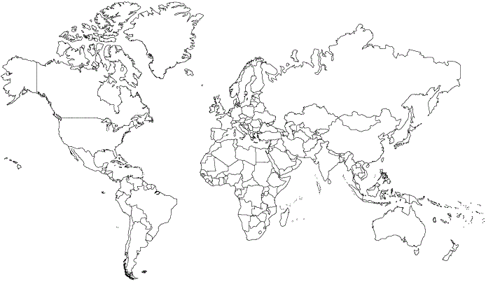
Shade in different colors what you would classify as different regions of the world. Make sure you name the regions and fill in the chart below. In 15 minutes we will debrief and come up with 1 common map.

Region Name/ color on your map | Why did you group this as a region?
COMMON REGIONS

Region Name/ color on your map | Why is this a region?

