1. Name 3 cities with large population densities:
a._________________
b._________________
c._________________

2. What do the most populated places have in common? What are they near? ____________________________________________________________________________________________________________________________________________________________________

3. Why do people like to live near your answer from #2?_________________________________________________________________________________________________________________________________________________________________

Part 2: Cultural Geography of the US and Canada
A. Language and Religion
Directions: Answer the following questions or complete the sentences.

1. What is the main language spoken in the United States and Canada?______________________
2. Quebec is an anomaly because they speak ___________________, which is the governmental
3. What is the main religion in the United States and Canada? ________________________
4. Describe why the United States and Canada are called “melting pots” ____________________________________________________________________________________________________________________________________________________________________

5. Quebec is different from Miami, Florida because:
A. In Quebec, they speak Spanish while in Miami they speak English
B. In Quebec the official language is English, while in Miami the official language is Spanish
C. In Quebec the official language is French while in Miami many people speak Spanish, but the official language is English
D. In Quebec and Miami, the official language is English, but French is spoken in Quebec and Spanish is spoken in Miami

B. Transportation:
Directions: Using figure 3 (loose sheet of paper with the maps on it) answer the following questions:

1. How has the distribution of highways changed since 1950?
______________________________________________________________________________________________________________________________________________________________________________________________________________________________________________________
2. Which part of the country has the most highways? Why do you think this is so?
______________________________________________________________________________________________________________________________________________________________________________________________________________________________________________________
3. What do you notice about the major cities? Are they near major highways or far off of them? Explain why they are near or far.
____________________________________________________________________________________________________________________________________________________________________
2. Directions: Analyze the following picture by answering the questions.
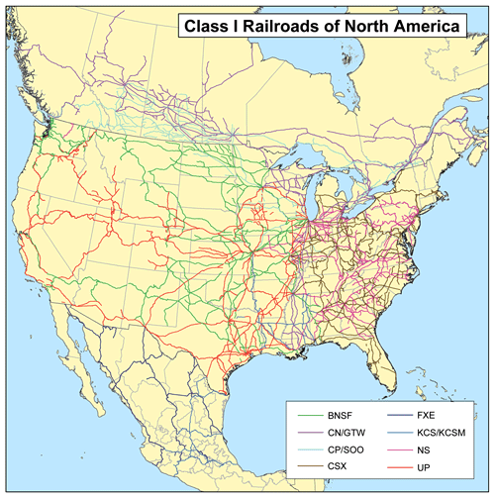
**ignore the legend at the bottom**

1. What is this map of?_________________________
2. Where are the most railroads according to this map?_________________________
_____________________________
_____________________________
_____________________________
3. Why do you think there are more railroads in these places?
_____________________________
_____________________________
_____________________________
_____________________________

4. Are most of the railroads in the same places as the major highways from figure 2? Explain why this may or may not be true.
______________________________________________________________________________________________________________________________________________________________________________________________________________________________________________________

C. The Environment –
Directions: Draw a comic strip below that shows the destruction of the environment. You can decide if you want to do water pollution, air pollution, smog, eutrophication, acid rain, or global warming. Make sure you show how this environmental concern was caused and what it is doing to the land/people in that area. Your comic strip must be 6 boxes. Make sure to give it a title!

