Name:_________________________ Date:______________________________ Class Period:_________________
ANNOTATIONS
1. Write the main idea of each section
2. Underline at least 10 geographic terms about Sub Saharan Africa
3. Circle at least 5 reasons why you would want to go on a safari
4. Note any other information that you find interesting

Safari 101: What You Need To Know About Travel to Africa
A trip to Africa is on a lot of bucket lists. For many of us in the United States, the continent seems majestic and mysterious yet dangerous and uncharted. Much of what we know about Africa is what we see in the media, a land of lions and giraffes, war and poverty. The Africa I know and love is a land of beauty and wonder that I have now dedicated my life to sharing with travelers.

Is travel to Africa safe?
Africa's biggest enemy is the international media (news reporters) who represent all 46 African countries as a single entity, and not as unique and individual countries with their own characteristics. It would come as a surprise to many people to find out that there are in fact areas that are worse off in more developed countries than in the "dangerous" African countries. No country can claim to be 100% safe, and so as with travel to any new or unknown destination, it is advisable to take certain standard security precautions. Visitors should take the same precautions as they would normally take in any other destination worldwide.

Where in Africa should I visit? What animals will I see?
The wildlife species found in the two areas are essentially the same; most of the predators and plains game can be seen in both regions and only some birds and a few mammals and reptiles are distinct between the regions. East Africa offers herds of zebras and wildebeests in the hundreds of thousands. The annual migration between the Maasai Mara in the north and Tanzania's Serengeti in the south is a spectacle unequaled anywhere on earth today. However, Botswana and Zimbabwe are home to 80% of Southern Africa's 300,000 elephants and huge herds are a common sight along their northern borders.

What are the different types of safaris?
The major differences between East Africa and Southern Africa for safaris are the density of tourists, the safari accommodations and the safari vehicles. East Africa, in general, has earned a reputation for a high density of tourists staying in hotel-styled lodges. The most common safari vehicle in East Africa is the mini-van with its pop-up roof, whereby passengers stand up to take pictures while peering out of the roof or sit in the enclosed vans. Conversely, Southern Africa is known for its luxury tented safari camps and huge tracts of wilderness areas with very low tourist densities, making for a private safari experience. The safari vehicles used here are modified, open-air Land Rovers which also add to the intimacy of the experience.
Besides animals, what else will I see?
Southern and Eastern Africa have many spectacular landforms that are specific to each region. For example, many safari goers are also interested in climbing Mt. Kilimanjaro, the dormant volcanic mountain, and also Africa’s tallest mountain, in Tanzania. Many people are also interested in seeing the beautiful Victoria Falls, on the border of Zambia and Zimbabwe. These waterfalls interrupt the Zambezi River, which flows from Botswana west through Zimbabwe and Mozambique until it meets the Indian Ocean in a delta, or triangular shaped deposit into the ocean. You can also see the Great Rift Valley, a depression in the earth formed by shifting tectonic plates, earthquakes, and volcanic eruptions millions of years ago. Along the Great Rift Valley are some of Africa’s few lakes that many safari goers want to stop at to take a swim. In particular, Lake Victoria is the largest lake in Africa and is located between the eastern and western branches of the Great Rift Valley. Unfortunately many of the lakes in Africa are shrinking due to desertification, global warming, and irrigation. Lake Chad is one of the many lakes that is shrinking, leaving the land around it dry and barren, destroying the vegetation around it. Safaris are a wonderful and exciting experience that few people get to enjoy in their lifetimes. If you every have the chance to take a trip on an African safari, you should because it is a unique way to get exposed to the geography and wildlife that African countries have to offer.
Questions: Before completing this section, make sure you have completed the annotations on the front.
1. What does the author mean when he says that International media often “represent all 46 African countries as one single entity and not as unique and individual countries with their own characteristics?”

______________________________________________________________________________________________________________________________________________________________________________________________________________________________________________________________________________________________________

2. Why is it harmful for International media to “represent all 46 African countries as one single entity and not as unique and individual countries with their own characteristics?”

______________________________________________________________________________________________________________________________________________________________________________________________________________________________________________________________________________________________________

3. Describe the difference between the safaris in Southern Africa and Eastern Africa.

__________________________________________________________________________________________________________________________________________________________________________________________________________________________________________________________________________________________________________________________________________________________________________________________________________________________________________________________________________________________________________

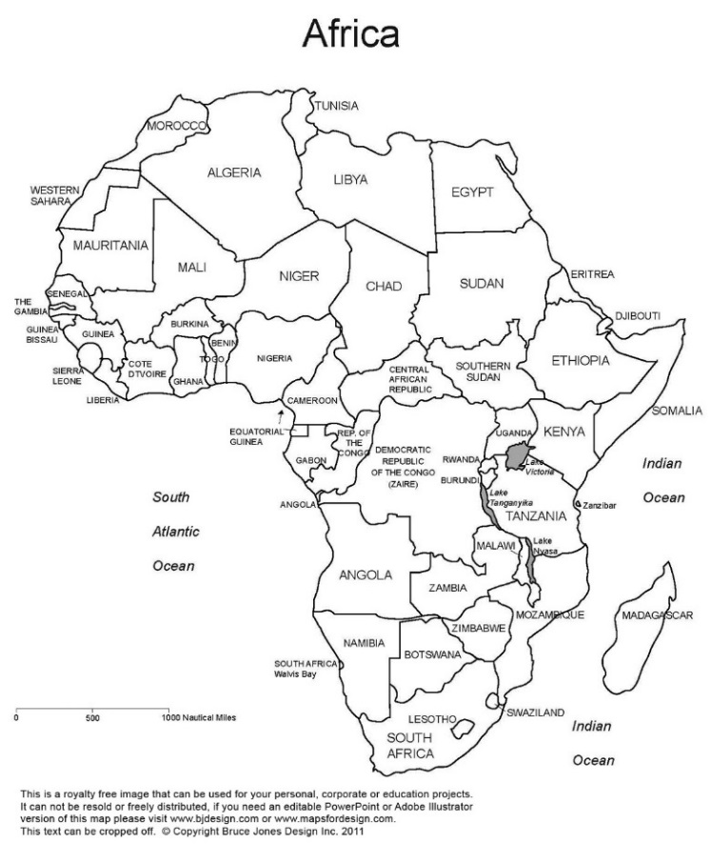
4. Choose two physical features of Sub Saharan Africa (landform or body of water) and do the following:
1. Place it on the map below
2. Write one significant fact about it

Geographic Features 1:

Geographic Feature 2:

5. Would you want to go on an African safari? Why? If yes, where do you want to go and what do you want to see?
________________________________________________________________________________________________________________________________________________________________________________________________________________________________________________________________________________________________________________________________________________________________________________________________________
__________________________________________________________________________________________________

