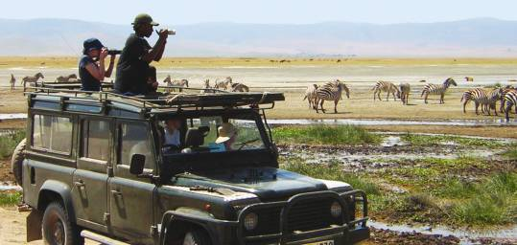
Unit 5 Day 1, Physical Geography of Sub Saharan Africa
1. Bell Ringer: answer the questions in the boxes below.

Describe the physical geography
Describe what people are doing
What title would you give this picture?
2. Video Guide: Watch the video and answer the questions below
The Lion King Clip: While watching the clip, answer the following questions:
- List 5 animals that you see:_________________________________________________________________________________________________________________________________________________________________________________________________________________________________________________________________

- Describe the land that you see (forests, desert, does it look like it rains? Grass?)_______________________________________________________________________________________________________________________________________________________________________________________________________________________________________________________________

- Do you think this representation of the land is realistic? Why or why not?_________________________________________________________________________________________________________________________________________________________________________________________________________________________________________________________________

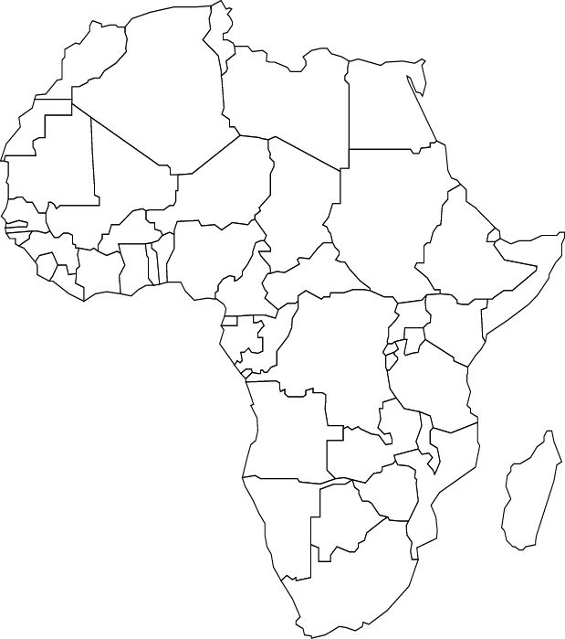
3. Annotate your maps according to the slides on the board. Locate the landform or body of water AND write one important fact about each.

