Name:_________________________ Date:___________________ Sunbelt Case Study

History of Sun Belt Growth

The Sun Belt is the region in the United States that stretches across the southern and southwestern portions of the country from Florida to California. The Sunbelt typically includes the states of Florida, Georgia, South Carolina, Alabama, Mississippi, Louisiana, Texas, New Mexico, Arizona, Nevada, and California. Major U.S. cities placed within the Sun Belt include Atlanta, Dallas, Houston, Las Vegas, Los Angeles, Miami, New Orleans, Orlando and Phoenix. However, some extend the definition of Sun Belt as far north as the cities Denver, Raleigh-Durham, Memphis, Salt Lake City and San Francisco.
The term "Sun Belt" is said to have been coined in 1969 by writer and political analyst Kevin Phillips in his book The Emerging Republican Majority to describe the area of the U.S. that encompassed the region from Florida to California and included industries like oil, military and aerospace but also many retirement communities. Following Phillips' introduction of the term, it became widely used in the 1970s and beyond. In the 1970s, Sun Belt became the official term to describe the area and growth continued even further as the U.S. south and west became more important economically than the northeast.

Reasons for the Sunbelt’s Growth

Part of the region's growth was a direct result of increasing agriculture and the earlier green revolution which introduced new farming technologies. In addition, because of the prevalence of agriculture and related jobs in the region, immigration in the area continued to grow as immigrants from neighboring Mexico and other areas were looking for jobs in the U.S.
On top of immigration from areas outside the U.S., the Sun Belt's population also grew via migration from other parts of the U.S. in the 1970s. This was due to the invention of affordable and effective air conditioning. It additionally involved the movement of retirees from northern states to the south, especially Florida and Arizona.
Milder winters in the Sun Belt also made the region attractive to retirees as much of it is relatively comfortable year-round and it allows them to escape cold winters. In Minneapolis, the average temperature in January is just over 10°F (-12°C) while in Phoenix it is 55°F (12°C).
Additionally, new types of businesses and industries like aerospace, defense and military, and oil moved from the north to the Sun Belt as the region was cheaper and there were fewer labor unions. This further added to the Sun Belt's growth and importance economically. Oil for example helped Texas grow economically, while military installations drew people, defense industries, and aerospace firms to the desert southwest and California, and favorable weather led to increased tourism in places like Southern California, Las Vegas and Florida.

Problems Faced in the Sunbelt

Despite this growth however, the Sun Belt did experience its share of problems in the 1980s and 1990s. For example, the region's economic prosperity has been uneven and at one point 23 out of the 25 largest metropolitan regions with the lowest per capita incomes (average income per person) in the U.S. were in the Sun Belt. In addition, the rapid growth in places like Los Angeles caused various environmental problems, one of the most significant of which was and still is air pollution.

The Sun Belt Today

Today, growth in the Sun Belt has slowed, but its larger cities still remain as some of the largest and fastest growing in the U.S. Nevada for example is among the nation's fastest growing states due to its high immigration..
The San Francisco Bay Area in California with the major cities of San Francisco, Oakland and San Jose still also remains a growing area, while growth in outlying areas like Nevada has decreased significantly due to nationwide economic problems. With this decrease in growth and outmigration, housing prices in cities like Las Vegas have plummeted in recent years. Despite recent economic problems, the U.S. south and west- the areas that comprise the Sun Belt still remain the fastest growing regions in the country, making the Sun Belt still, as it has been since the 1960s, one of the most important growth regions in the U.S

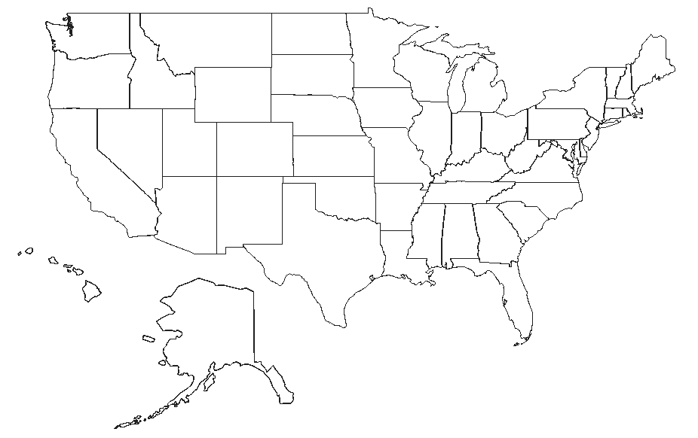
1. Shade in the Sunbelt on the map.

2. In ONE complete sentence, write down the thesis of this article. _____________________________________________________________________________________________________________________________________________________________________________________________________________________________________________________________________________________________________________________.

3. Cite 3 details from the text that support your thesis. Include the paragraph number in your answer.
a. ______________________________________________________________________________________________
b. ______________________________________________________________________________________________
c. _______________________________________________________________________________________________

4. Describe the Sunbelt’s physical geography:___________________________________________________________________________________________________________________________________________________________________________________________________________________________________________________________________________________________________________________________________________________________________________________________________________________.
5. How has the physical geography of the Sunbelt determined what activities and industries are in this region? What activities and industries are most prominent in this region? _____________________________________________________________________________________________________________________________________________________________________________________________________________________________________________________________________________________________________________________.
6. List 3 reasons why people move to the Sunbelt:
a.______________________________________________________________________________________________
b. ______________________________________________________________________________________________
c. _______________________________________________________________________________________________

