Most least common | Name of language | Countries where it is spoken (2 examples) | # of speakers worldwide
10
9
8
7
6
5
4
3
2
1
Part 1. Directions: Use the info given to you to fill in the chart about the most and least common languages in the world.

GOING DEEPER QUESTIONS
1. Which languages had you never heard of on this list? __________________________________________________________________________________________________________________________________________________________________________

2. What are some possible reasons as to why some languages are so widespread? _________________________________________________________________________________________________________________________________________________________________________

3. How does language help define a culture?
__________________________________________________________________________________________________________________________________________________________________________

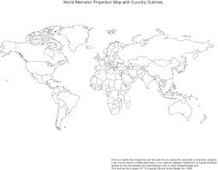
Part 2. Directions: Map it! Using the map below, and page RA 6 in the textbook as a reference, shade in and label 1 country where each of the top 10 most common languages are spoken. You should have at LEAST 10 countries shaded in and labelled on your map. Then answer the questions below.

1. Are the countries where the TOP 10 most common languages are spoken in one region or spread out all over the world? __________________________________________________________________________________________________________________________________________________________________________

2. Why is it important to learn multiple languages and to know what languages are spoken in foreign countries? __________________________________________________________________________________________________________________________________________________________________________

3. What is one reason why the number of people who speak Chinese is so much greater than any other language? _______________________________________________________________________________________________________________________________________________________________________________________________________________________________________________________________

