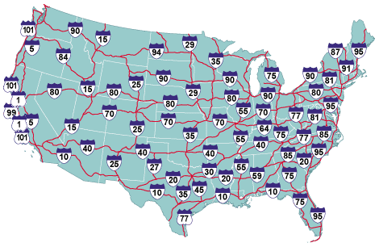
UNITED SATES INTERSTATE HIGHWAYS 4-LEVEL MAP ANALYSIS

Level 1: WHAT- What is this map showing us?
Level 2: WHERE- Where are the highways located? Where is this map of? What do the highways connect? How long do they go?
Level 3: WHY THERE- Why are these highways located in these specific spots? What do they connect and why?
Level 4: SO WHAT- How does this impact the United States both positively and negatively?

Transportation systems in the United States and Canada 9/2/14
Both Canada and the United States have had major developments in transportation systems in the last 100 years. They both have a very sophisticated railroad system, many major international airports, advanced highway systems, and it is easy to get from one place to another throughout the United States and Canada.
ENVIRONMENTAL CONSEQUENCE | DESCRIPTION | PICTURE/IMAGE
SMOG
AIR POLLUTION
WATER POLLUTION
ACID RAIN
EUTROPHICATION
GLOBAL WARMING
Other issues: traffic & crowding

