Name:___________________________ Date:_____________________ Section:____________________

Test date:
A day- Aug 20
B Day- Aug 21

Concepts to know:
1. The 5 themes of Geography
Theme | Meaning | Real World Example
Place

Location
Region
Human Environment Interaction
Movement

2. Aspects of Physical Geography – know how to read a physical map, natural resource map, and climate map
A. Landforms- types and purposes (isthmus, mountains, plains, mesa, peninsula)
B. Bodies of Water- types and purposes
C. Natural Resources- types and purposes
D. Climate – effects on people and geography

3. GIS/GPS- meanings and purposes

4. Top 10 major modern migrations (know where they happened, why, and what the impact was)
-Iberia to Latin America
-Northwest Europe to North America
-West Africa to Brazil, Caribbean, American South
-China to SW Asia and NW North America
-British Isles to Australia, New Zealand, South Africa
-India to British Empire
-Western Russia to Siberia
-Israel from The Middle East and Europe
-To the US from Latin America
-To Western Europe from The Middle East

5. The difference between rural & urban

6. Population density- what it is and how to read a population density map- Where are more people? By the coasts or inland?

7. Culture- definition and elements of culture

8. Religions- know the major religions of the world and some of their main practices. Know which are more widespread.

Hinduism-

Buddhism-

Christianity-

Islam-

Judaism-

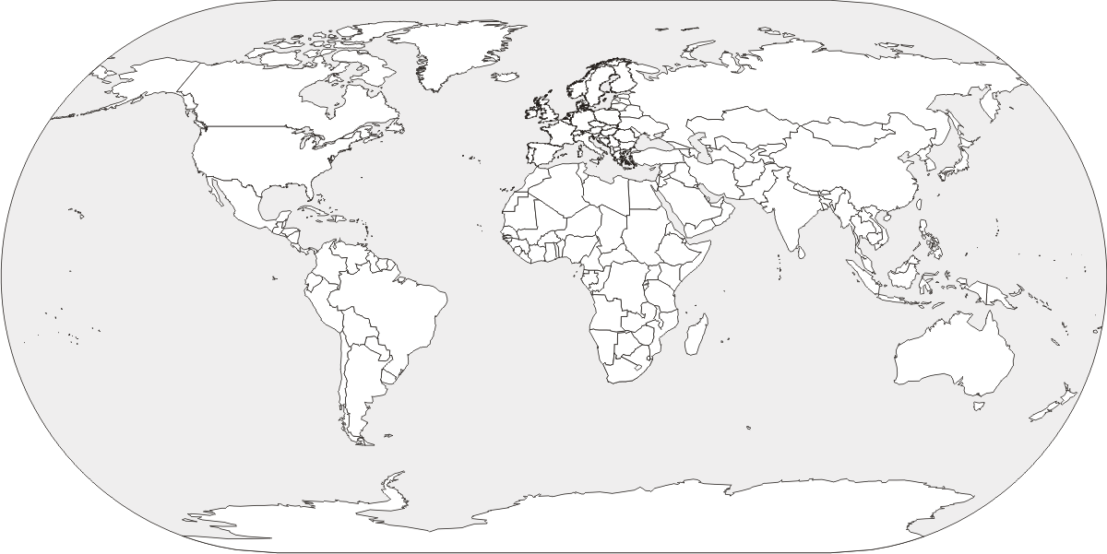
9. World Map- locate the continents and oceans on a blank map (Antarctica, Arctic Ocean, Pacific Ocean, Africa, Atlantic Ocean, Asia, North America, Europe, South America, Australia, Indian Ocean)
Sample Questions:

1. All of the following are reasons why rivers are important to a region EXCEPT:
A. it can provide hydroelectric power
B. It can make the surrounding land fertile
C. It can provide fresh drinking water
D. They can connect continents from across the world

2. Most natural resources provide a place with ___________________ or ________________
A. gold, silver
B. money, energy
C. Control, independence
D. Climates, landforms
3. The migration of people from Latin America to the US is similar to the migration of people from the Middle East to Europe because:
A. They are both in search of better jobs and are working as guest laborers
B. They are both escaping religious persecution
C. They are migrating across the world
D. They are all illegal immigrants

4. The most widespread religion in the world is:
A. Judaism
B. Christianity
C. Islam
D. Hinduism

