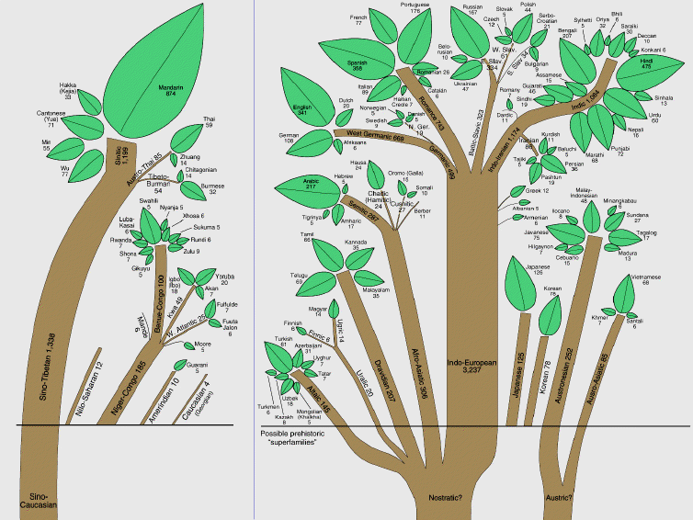
Unit 4: Language 10/30/14

I. Review

a. Language Tree

Language ________________
↓
Language ________________
↓
Language ________________
↓
Language

b. Example- English:

II. Mapping Language

a. World Language Families Choropleth Map

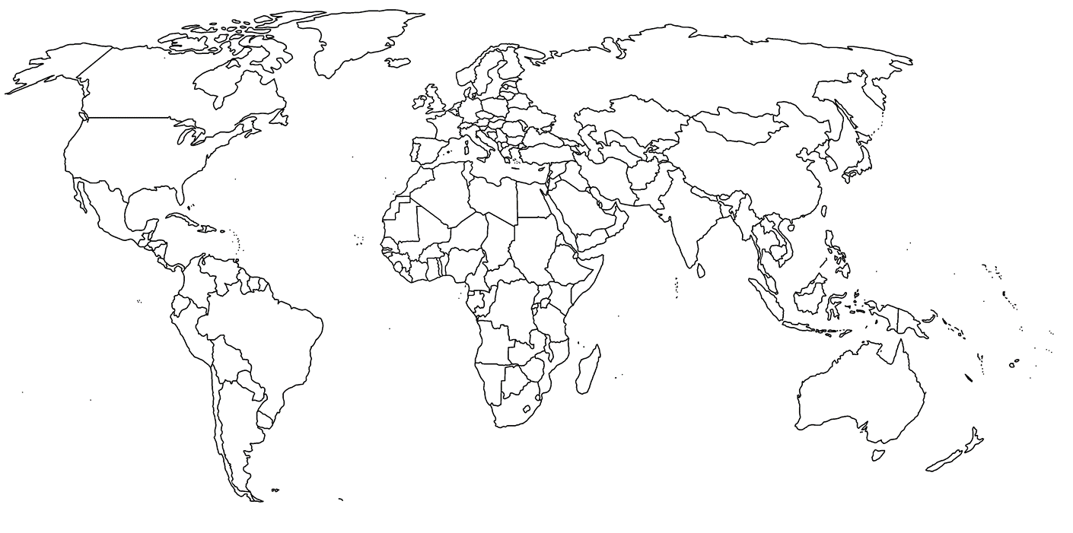
Directions: Using your homework notes, create a choropleth world map of the distribution of major language families. Make sure to include a color coded key.
b. Mapping Indo European Branches in Europe

Directions: Using the map on pg. 174, make a choropleth map of the Indo European language branches in Europe. Include a color coded key. Only include the Germanic, Romance, and Slavic language branches.
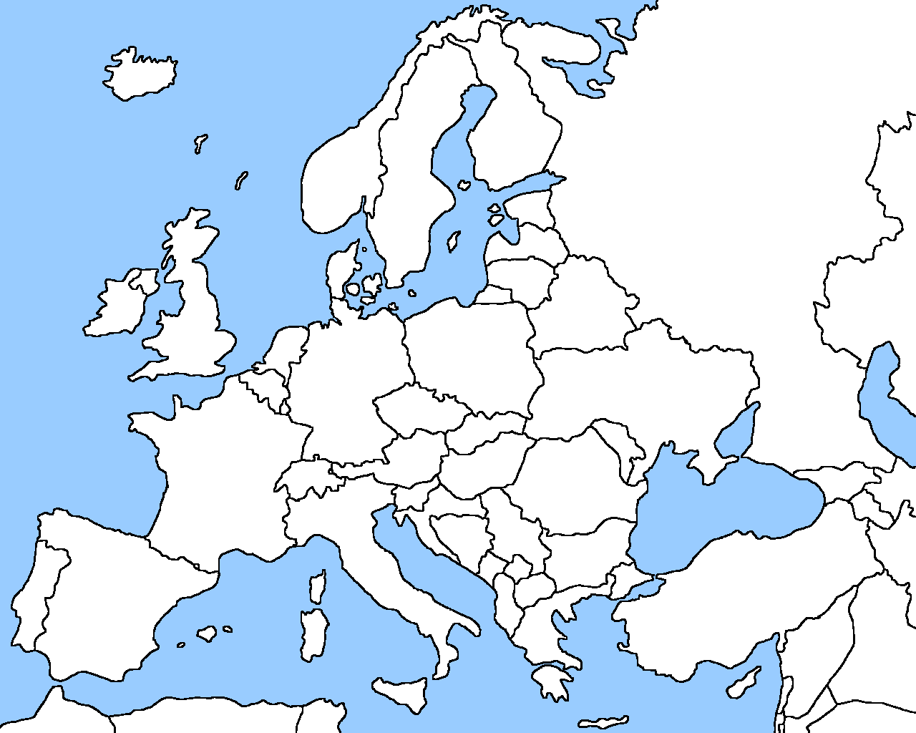

C. Mapping English’s origins and diffusion

Document Based Questions
Directions: Use the 10 documents in the folder to answer the following questions:

1. According to document 1, how many continents have English speaking countries? _____

2. Using documents 2,3,4, & 5, describe the presence of English on the internet. _______________________________________________________________________________________________________________________________________________________________________________________________________________________________________________________

