Unit 6, Day 1 Physical Geography of Asia
A day 11/10, B day 11/11

1. Bell Ringer: Put the words below into the correct boxes.

China, East Asia, Beijing, India, Japan, Tokyo, South Asia, Mumbai, Indonesia, Korea, Central Asia, Shanghai

Region | Country | City

2. Physical Geography of Asia notes. Location, Landform, Affect & Effect.

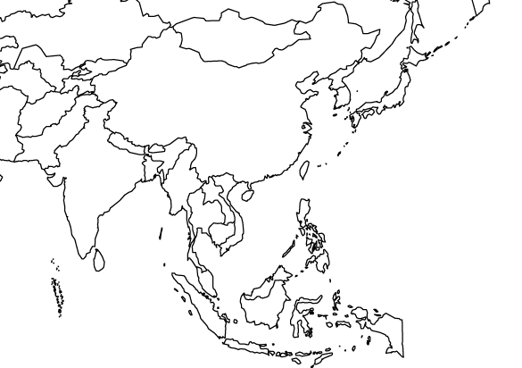

3. Document Based Questions: Use the documents in the folder to answer the questions below. Use document 5 as a reference for all questions.

1. According to document 1, describe the main climates in Asia. (Are there many climates, few climates, are they all dry or wet or combination?) ____________________________________________________________________________________________________________________________________________________________________________________
__________________________________________________________________________________________
2. According to document 2, which 3 countries of Asia has the highest population densities? __________________________________________________________________________________________

3. Why do you think those countries have the highest population densities? (Use documents 1-4) ____________________________________________________________________________________________________________________________________________________________________________________

4. According to documents 3 & 4, which country in Asia has the most oil as a natural resource? ____________________________

5. According to document 1, how do the climates of the Malay Archipelago differ from the rest of Asia? Describe what the average weather might be like there.
____________________________________________________________________________________________________________________________________________________________________________________

6. Using document 1 and your map notes, is the population high or low in the Gobi Desert? What causes it to be high or low? ______________________________________________________________________________________________________________________________________________________________________________________________________________________________________________________________________________

7. According to documents 3 & 4, which Asian country has the most manufacturing and trade? ________________________

8. How does the United States help that country have more factories and manufacturing industries? Why does the United States do this? ______________________________________________________________________________________________________________________________________________________________________________________________________________________________________________________________________________

9. Describe why the population density is higher in Eastern China and lower in Western China. ____________________________________________________________________________________________________________________________________________________________________________________

10. According to Document 6, which months receive the most rain in Cherrapunji, India? ____________________________________________

11. Using documents 7 & 8, describe how the heavy monsoon rains in India have both a positive AND negative impact on the people, animals, and land of India. _____________________________________________________________________________________________________________________________________________________________________________________________________________________________________________________________________________________________

