Name:______________________________Date:_______________________________Class Period:________________

World Geography Midterm Study Guide

Complete the following study guide and put it in your binder.

Part 1. Vocabulary- Write a short description, the importance, or draw a picture of each term below.

- Landform

- Natural Resource

- Culture

- Geography

- Mississippi River

- Rocky Mountains

- Great Plains

- Appalachian Mountains

- Canadian Shield

- Amazon Rainforest

- Amazon River

- Andes Mountains

- Ring of Fire

- Matriarchal

- Indigenous

- Mestizo

- Syncretism

- Climate

- Hydroelectric power

- Campesino

- Nile River

- Sahara Desert

- Arabian Peninsula

- Rub’ al-Khali

- Water Crisis in the Middle East

- Desalination

- Deforestation

- Smog

- Global Warming

Part 2: Put the information in the Venn diagram below.
Andes Mountains, Hydroelectric Power, Oil, Wind Power, Rocky Mountains, Appalachian Mountains, Nile River, Western Hemisphere, Christianity, Diverse, Developing Countries, Atlantic Ocean, Ring of Fire, Gulf of Mexico, Desalination, Deforestation,

Part 3: Answer the following questions.

1. Describe an oasis in the Sahara Desert and give an example. Pg. 425

2. List 3 reasons why the earthquake in Haiti was so destructive.

3. Does the general population in the Middle East benefit from the oil that is there? How do you know?

4. Describe the effects of growing transportation on the environment in the United States.

5. Describe the climate in the Middle East. Pg. 416

6. Describe the significance of the Rocky Mountains (hint: think about natural resources). Pg. 131

Part 4: Map Work: Label the following regions on the map: Latin America, United States/Canada, Middle East, Sub Saharan Africa, Europe, Asia, Australia, and Antarctica.
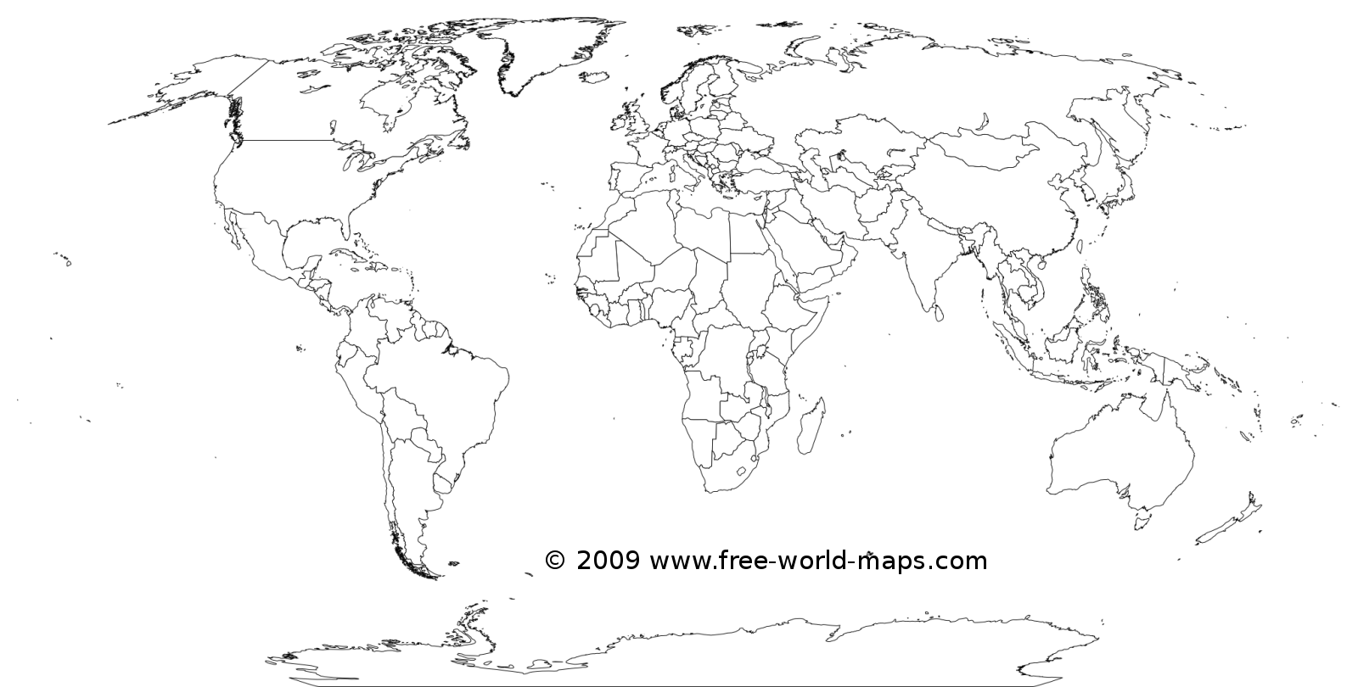

Part 5: Practice Questions
1. Which feature is considered a natural barrier?
(1) Mississippi River
(2) Aswan Dam
(3) Panama Canal
(4) Great Wall of China

2. Geopolitics play an important role in the Middle
East today because of its
(1) fertile soil and favorable climate for cash crops
(2) navigable rivers and diamond mines
(3) effective natural barriers and high altitude
(4) strategic location and oil resources

- Extinction of endangered species
- Industralization and growing businesses
- Selling timber (wood)
3. All of the points above refer to:
(1) deforestation in the Amazon Rainforest
(2) Drying out of the Aral Sea
(3) desalination of water in the Middle East
(4) Acid rain in the United States

4. The main reason oil-producing states formed the
Organization of Petroleum Exporting Countries
(OPEC) was to
(1) promote foreign ownership of oil fields
(2) lift economic sanctions and establish free trade
(3) improve trade relations with the West
(4) influence the price of oil and set production level
Part 6: Choose 4 of the terms from part 1 and write a multiple choice question for each of them below.

