DO NOT WRITE ON THIS TEST
World Geography Unit 1 Exam

Part 1. Multiple Choice (2 points each)
SSWG1

1. All of the following are reasons why rivers are important to a region EXCEPT:
A. it can provide hydroelectric power
B. It can make the surrounding land fertile
C. It can provide fresh drinking water
D. They can connect continents from across the world

2. Most natural resources provide a place with ___________________ or ________________
A. gold, silver
B. money, energy
C. Control, independence
D. Climates, landforms

3. The migration of people from Latin America to the US is similar to the migration of people from the Middle East to Europe because:
A. They are both in search of better jobs and are working as guest laborers
B. They are both escaping religious persecution
C. They are migrating across the world
D. They are all illegal immigrants

4. The __________ in Atlanta is 80 degrees and sunny.
- Climate
- Weather
- Temperature
- Altitude

5. A narrow strip of land that connects two larger strips of land is called:
A. Isthmus
B. Mesa
C. Mountain
D. Peninsula

6. Which of the following bodies of water would be most likely to produce hydroelectric power?
A. Lake
B. Pond
C. Stream
D. River

7. What do the Tundra, Arctic, and Subarctic climates have in common?
A. They are all in the Southern Hemisphere
B. They are all in tropical islands
C. They are all very cold
D. They are only in the mountains

8. The migration of people from Iberia (Spain and Portugal) to Latin America spread…
A. Islam to the Middle East)
B. Spanish to Latin America and Portuguese to Brazil
C. English to the Americas
D. This migration did not occur

9. The migration of people from West Africa to Brazil, the Caribbean, and the American South occurred as a result of:
A. African tribal wars
B. The Great Depression
C. A Civil War
D. The Slave Trade

10. Josh lives in Los Angeles and enjoys wearing board shorts, going to the beach, surfing, and collecting sunglasses. This is an example of:
A. culture
B. physical geography affecting culture
C. Natural resources
D. Landforms affecting religion

11. Population densities tend to be higher near:
A. Mountains
B. Mesas
C. Coastal areas or large bodies of water
D. Eastern Africa and Western Europe

12. Which of the following is not one of the oceans in the world:
A. Arabian
B. Indian
C. Atlantic
D. Pacific

13. Population density is measured in:
A. People per foot
B. People per country
C. People per city
D. People per square mile

14. Each climate region has its own kind of:
A. rock structure
B. tectonic plate
C. natural vegetation
D. Coriolis effect

15. Which of the following would NOT be found on plains?
A. Grass
B. Crops
C. Small hills
D. Mountains

SSWG2

16. Regions are define by:
A. Only location
B. Country borders
C. Places that have similarities
D. The way people interact with the environment

17. The most widespread religion in the world is:
A. Judaism
B. Christianity
C. Islam
D. Hinduism

18. __________ is the dominant religion in the Middle East
A. Islam
B. Judaism
C. Hinduism
D. Christianity

19. Islam, Judaism, and Christianity are all:
A. Polytheistic
B. Monotheistic
C. Nontheistic
D. Originating in Jerusalem

20. Some say that Buddhism is not actually a religion because
A. It is monotheistic
B. They have many gods
C. They do not pray
D. They worship a person (Buddha), and not a God

21. The most widely spoken language in the world is _____________________ because
A. English, many countries speak English as their first language
B. Mandarin Chinese, China’s population is the largest in the world
C. German, Germany’s population is the largest in the world
D. Hindi, Indian people are spreading Hindi by moving all over the country

22. Culture is
A. A set of beliefs
B. A combination of beliefs, activities, race, ethnicity, and physical geography
C. Religion
D. Language and religion

23. Religions are often most dominant in one particular region of the world.
A. True
B. False

24. Latin America is grouped together as a region because:
A. All of the countries are in South America
B. The countries practice similar religions, speak the same language, and similar practices
C. They all speak Spanish
D. They all eat the same food and do the same dances

25. The religion with the smallest followers worldwide is:
A. Christianity
B. Islam
C. Hinduism
D. Judaism

26. Physical geography can impact culture by:
A. determining what activities and clothing can be done and worn there
B. people worshipping landforms
C. Migrations spreading language and religion
D. Water producing hydroelectric power

27. Most religions…
A. Have the same beliefs and practices
B. Believe in reincarnation
C. Are prominent in their place of origin
D. Read the Holy Bible

28. According to Hindu beliefs, if a person has good ______________, then they will be reincarnated into:
A. Karma, a rat
B. Dharma, the same person
C. Karma, the same person
D. Karma, a powerful person or animal

29. The ultimate goal of Buddhists is to reach
A. Nirvana, which means being reborn into a better animal or person
B. Hanukkah, which is ultimate happiness
C. Nirvana, which means complete happiness
D. Allah, which is praise from elders

30. Both Buddhism and Hinduism
A. Are monotheistic
B. Originated in India and are prominent in Asia
C. Read the Vedas as their holy text
D. Desire to reach Nirvana

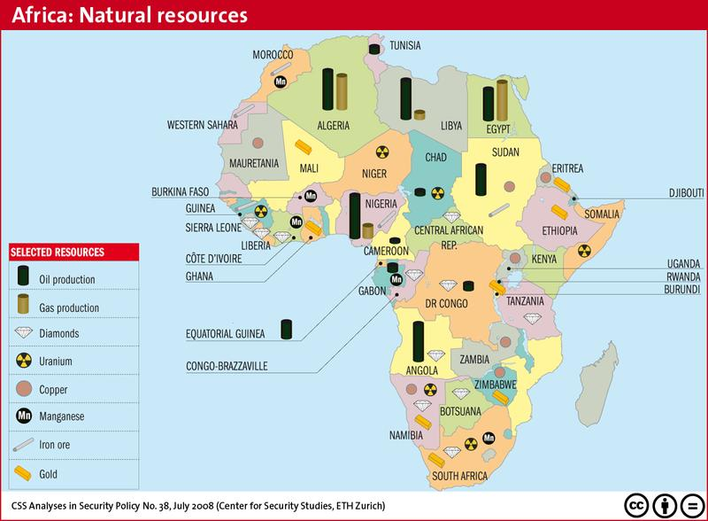
Part 2: Map Skills (2 points each)

Questions 31- 33 refer to Figure 1

31. Which natural resource is most prominent in
West Africa?
A. Oil
B. Copper
C. Diamonds
D. Uranium

32. Which natural resource is most prominent in North Africa?
A. Oil
B. Diamonds
C. Iron Ore
D. Uranium

33. Which country has the largest variety of natural resources?
A. Algeria
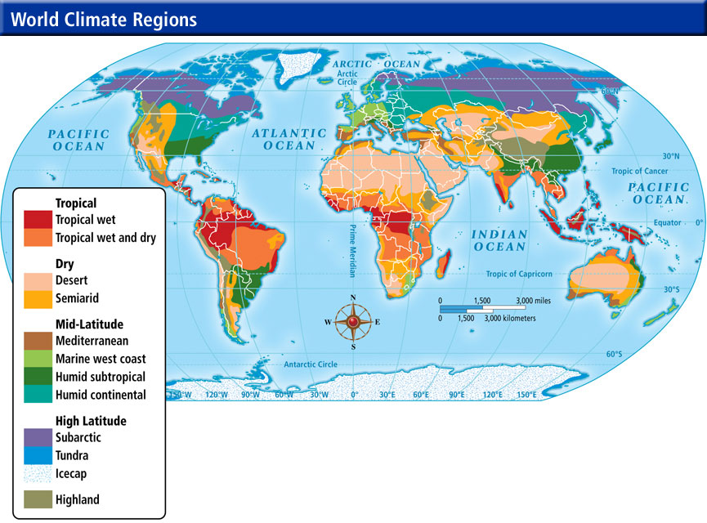
B. South Africa
C. Zimbabwe
D. Kenya

Questions 34 – 36 refer to figure 2

34. The Southern Hemisphere tends
To have
A. Tropical climates
B. High Latitude climates
C. Mid Latitude climates
D. Icecaps

35. In the United States there are 3 main climates. They are
A. semiarid, tropical wet, and tundra
B. semiarid, highland, and humid continental
C. humid continental, semiarid, and humid subtropical
D. Humid continental, subarctic, and tropical wet

36. The climate in Atlanta is:
A. Tropical wet
B. Ice cap
C. humid continental
D. Humid subtropical.
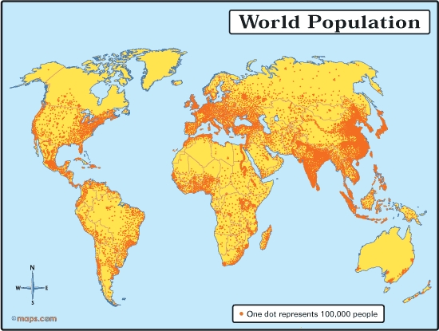
Questions 37 & 38 refer to figure 3

37. In South America, most of the
Population is
A. Inland
B. In Mexico
C. On the coasts
D. In the Northern part

38. Which area is least populated:
A. Northeast United States
B. India
C. Europe
D. North Africa

Questions 39 &40 refer to
Figures 2 & 3

39. Russia and Northern Canada have very low populations according to figure 3. According to figure 2, they also have
A. Humid climates
B. Subarctic/tundra climates
C. Tropical wet climates
D. Desert climates

40. The Middle East and Central Australia have low populations according to figure 3. According to figure 2, they also have
A. Humid Climates
B. Subarctic/tundra climates
C. Tropical wet climates
D. Desert climates

Part 3: Short Response Question (5 points) – choose ONE of the following questions to respond to in 1 paragraph or less

1. Give an original example of how physical geography can affect cultural geography

2. Describe a place (any place you’ve been to) using only physical geographic terms

Part 4: Extended response question (15 points) – Respond to the following prompt in 2-3 paragraphs

The 5 themes of geography are place, location, region, human-environment interaction, and movement. In 2-3 paragraphs, describe each of these themes, give a real world example for each, and discuss how these themes are interconnected.

BONUS (up to 5 points)
1. Where does homework get handed in?
2. What is the FIRST thing you do when you walk into class?
3. Explain 3 ways you can get the work if you miss class

